ADVANCED TECHNOLOGY RESOURCES CONSTRUCTION CORP.
FEASIBILITY STUDY REPORT · REVISION 2
Bulacan 20 CMS Bulk Irrigation Water Substitute Project
5-Hectare High-Resilience Abstraction Complex & 43.2 km Conveyance Corridor
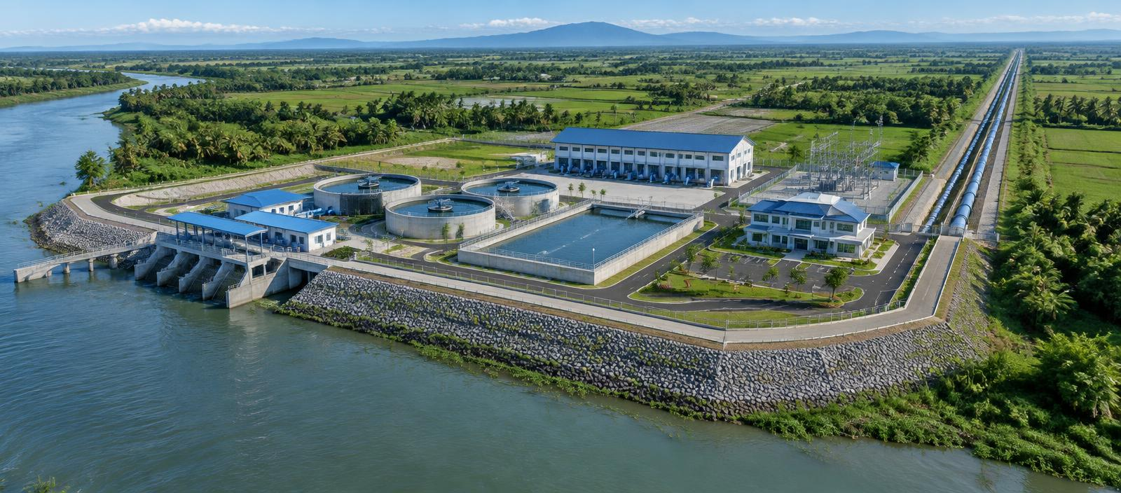
Conceptual project visualization · Revision 2 basis · Not for construction
20.00 CMS  1.728M m³/day | 5.0 ha  Sta. Cruz Pambilog, San Luis | ₱14.85 B  Controlled CAPEX | 18.20% / 23.50%  FIRR / EIRR

Document control | Issue information
Sponsoring organization | Advanced Technology Resources Construction Corp.
Reviewing entities | NIA · MWSS · NEDA · DENR · private concessionaires · lenders
Document code / revision | ATRCC-BUL-2026-FS-REV2 · Revision 2
Issue date / status | September 28, 2026 · Executive feasibility basis
Distribution classification | Controlled review copy · Not for construction

Document Control and Status
Controlled feasibility basis · September 2026
This document supersedes earlier project descriptions only where the controlling 2026 five-hectare parameters, CAPEX schedule, package groupings, and financial corollaries are expressly stated. Historical material retained from the source report is presented as context and does not override the revised basis.
Status: executive feasibility basis for validation and decision review. The report is not a water permit, environmental approval, lending commitment, construction issue drawing, or substitute for independent engineering and financial due diligence.
Control | Value
Document code | ATRCC-BUL-2026-FS-REV2
Issue date | September 28, 2026
Configuration | 2026 · 5-hectare case
Primary reference | 79-page supplied feasibility study
Controlling updates | Three supplied CAPEX and financial schedules

Table of Contents
Complete section and annex index
Document Control and Status 1
Lists of Figures, Tables, Annexes and Abbreviations 5
Executive Summary — Strategic Case 7
Executive Summary — Engineering Configuration 8
Executive Summary — Investment and Decision Case 9
1.1 Background and Water-Security Context 11
1.2 Project Purpose and Objectives 12
1.3 Objectives and Scope of the Study 13
1.4 Institutional and Policy Setting 14
1.5 Study Methodology and Information Hierarchy 15
2.1 Project Location and Accessibility 16
2.2 Existing Physical Features 17
2.3 Topography, Drainage and Flood Setting 18
2.4 Climate and Seasonal Conditions 19
2.5 Existing Irrigation System and Service Area 20
2.6 Five-Hectare Site Allocation 21
2.7 Conveyance Corridor and Rights-of-Way 23
3.1 Available Water and Source Reliability 24
3.2 Climate and Rainfall Information 25
3.3 Meteorological Data Review 26
3.4 AMRIS Water Demand and Substitution Logic 27
3.5 Design Flow and Operating Availability 28
3.6 Flood Levels and Freeboard 29
3.7 Sediment, Salinity and Water Quality 31
3.8 Hydrologic Verification Program 32
4.1 Geological Environment 33
4.2 Investigation Methodology 34
4.3 Drilling, Sampling and Laboratory Testing 35
4.4 Groundwater and Consolidation Conditions 36
4.5 PVD and Surcharge Treatment 37
4.6 Stone-Column Treatment 38
4.7 Geotechnical Conclusions and Verification 39
5.1 Development Concept and Design Criteria 40
5.2 River Intake and Screening 41

Table of Contents — continued
Complete section and annex index
5.3 Low-Lift Pump Station 42
5.4 Vortex Desanding and Sediment Handling 43
5.5 Balancing Forebay 44
5.6 High-Lift Pump Station 45
5.7 Electrical Supply, 69 kV Substation and SCADA 46
5.8 Surge Protection and Operational Control 47
5.9 Twin-Barrel Transmission Corridor 48
5.10 Bustos Dam / AMRIS Terminal Works 49
6.1 Project Description for Safeguards Review 50
6.2 Physical Environment 51
6.3 Biological Resources 52
6.4 Community and Quality-of-Life Conditions 53
6.5 Construction Impacts and Mitigation 54
6.6 Operational Impacts and Monitoring 55
6.7 Institutional Requirements and Public Involvement 56
6.8 Safeguards Findings and Commitments 57
7.1 Cost Estimate Basis and Assumptions 58
7.2 Detailed CAPEX Schedule 59
7.3 Work-Package Grouping 61
7.4 Procurement and Contract Packaging 63
7.5 Thirty-Six-Month Construction Program 64
7.6 Cost Control and Contingency Governance 65
8.1 Basic Financial Assumptions 66
8.2 Revenue, OPEX and EBITDA 75
8.3 Capital Structure and Debt Terms 76
8.4 Debt-Service Capacity 77
8.5 Project and Equity Returns 79
8.6 Economic Evaluation 80
8.7 Sensitivity and Scenario Analysis 81
8.8 Financial Conclusions and Audit Requirements 82
9.1 Consolidated Findings 83
9.2 Critical Risks and Mitigation 84
9.3 Decision Gates 85
9.4 Recommendation and Next Actions 86

Table of Contents — continued
Complete section and annex index
Annex A — Parameter Register and Revision Matrix 87
Annex B — Complete CAPEX Schedule 89
Annex C — Package Grouping Summary 91
Annex D — Financial Corollaries and Return Metrics 92
Annex E — Fifteen-Year Debt-Service Profile 93
Annex F — Environmental and Social Commitment Register 95
Annex G — Risk Register and Allocation Matrix 97
Annex H — Implementation Milestones and Decision Gates 98
Basis, Limitations and Professional Reliance 98

Lists of Figures, Tables, Annexes and Abbreviations
Controlled feasibility basis · September 2026
The following registers identify the report-native figures, controlled tables, annexes, and abbreviations used throughout this study. Figure page references are carried in the complete contents index and chapter headings.
Figure | Title
Figure 1-1 | Strategic water-substitution pathway
Figure 2-1 | Conceptual five-hectare functional allocation
Figure 2-2 | Schematic 43.2 km conveyance corridor
Figure 3-1 | Flood-resilience design elevations
Figure 4-1 | Conceptual soil profile and ground-treatment zones
Figure 5-1 | Two-stage hydraulic process
Figure 5-2 | Conceptual pump-station arrangement
Figure 5-3 | Indicative hydraulic grade line along the corridor
Figure 6-1 | Safeguards monitoring framework
Figure 7-1 | CAPEX by controlled work-package group
Figure 7-2 | Distribution of the 16 controlled CAPEX items
Figure 7-3 | Controlled 36-month implementation sequence
Figure 8-1 | Year 1 operating case
Figure 8-2 | Illustrative 15-year DSCR profile
Figure 8-3 | Selected operating sensitivities
Figure 9-1 | Pre-mitigation risk heat map
Figure 9-2 | Gated route to investment commitment

Principal Tables
- Key project parameters and site allocation
- Pump-duty and flood-elevation schedules
- Sixteen-item CAPEX and five-package summaries
- Financial assumptions, Income Statement, Cash Flow, Balance Sheet, and debt-service profile
- Environmental commitments, risk allocation, and decision gates

Annexes and Abbreviations
Annexes A–H provide the revision matrix, complete cost schedules, financing metrics, debt profile, safeguards register, risk matrix, and implementation gates.
AMRIS — Angat-Maasim Rivers Irrigation System; CMS — cubic metres per second; DENR — Department of Environment and Natural Resources; DSCR — debt service coverage ratio; EPCM — engineering, procurement and construction management; FIRR — financial internal rate of return; FNPV — financial net present value; NEDA — National Economic and Development Authority; NIA — National Irrigation Administration; PVD — prefabricated vertical drain; ROW — right-of-way; SCADA — supervisory control and data acquisition; TDH — total dynamic head; VFD — variable-frequency drive.

Executive Summary — Strategic Case
Controlled feasibility basis · September 2026
The project is an independent bulk-water substitution investment intended to replace 20.00 CMS of AMRIS irrigation supply otherwise released from Angat storage. Water is abstracted from the lower Pampanga River at Barangay Sta. Cruz Pambilog, San Luis, Pampanga and conveyed to the Bustos Dam / AMRIS headworks.
The revised feasibility basis distinguishes controlling 2026 assumptions from contextual information retained from the source report. Regional proposals are referenced only where they explain basin conditions; they are not institutional or financial dependencies of this project.
Progression beyond feasibility requires confirmation of source yield, enforceable offtake arrangements, statutory approvals, corridor control, and independent technical and financial review.

Executive Summary — Engineering Configuration
Controlled feasibility basis · September 2026
The abstraction complex occupies 50,000 m², approximately 250 m along the river by 200 m deep. Its five functional zones allocate 1.0 ha to intake and low-lift pumping, 1.5 ha to desanding and forebay, 1.2 ha to high-lift pumping and the substation, 0.8 ha to flood management, and 0.5 ha to operations and access.
The 43.2 km conveyance corridor must preserve hydraulic performance while managing road, waterway, utility, property, and community interfaces. Permanent access is required at isolation valves, air valves, drainage points, crossings, and cathodic-protection facilities.
Parcel verification, cadastral surveys, utility mapping, geohazard screening, and livelihood planning remain preconditions to route freeze.
The process chain combines screened river abstraction, low-lift pumping, vortex desanding, 60,000 m³ balancing storage, high-lift pumping, surge control, and twin-barrel conveyance to the AMRIS terminal.
Stage 1 provides nine 2.5 CMS vertical turbine pumps in an eight-duty plus one-standby arrangement at 7.5 m TDH with 250 kW VFD motors. Stage 2 provides nine horizontal split-case double-suction pumps on the same duty basis at 28.5 m TDH with 1,050 kW, 6.6 kV VFD motors.
A 69 kV dual-bus substation with two 25 MVA transformers, SCADA telemetry, automated flow measurement, standby systems, and hydropneumatic surge anticipation supports resilient operation.

Executive Summary — Investment and Decision Case
Controlled feasibility basis · September 2026
The revised capital requirement is exactly ₱14,850.00 million across sixteen controlled items. The estimate explicitly recognizes the five-hectare platform, flood defenses, ground treatment, two-stage pumping, 43.2 km corridor, terminal works, safeguards, contingencies, pre-operations, and financing costs.
Implementation is organized into enabling and ground-improvement works in months 1–10; civil structures and corridor works in months 7–26; equipment installation and energization in months 20–33; and wet commissioning, reliability testing, and handover in months 32–36.
Cost assurance requires package-level estimates, indexed procurement assumptions, quantified risk analysis, independent certification, change control, and reconciliation to the approved cost baseline.
The base financing case uses 70% senior debt of ₱10,395.00 million and 30% sponsor equity of ₱4,455.00 million. Debt is stated at 6.50% per annum over 15 years with a three-year construction grace period.
At ₱14.50/m³ and 95% availability, Year 1 gross revenue is ₱8,688.17 million. Year 1 OPEX is ₱2,223.65 million, producing EBITDA of ₱6,464.52 million and a 74.4% margin.
Controlling returns are project FIRR 18.20%, equity FIRR 21.50%, FNPV at 8.5% WACC of ₱16,850 million, minimum and average DSCR of 1.65x and 2.15x, EIRR 23.50%, and ENPV at 10% SDR of ₱29,500 million.
The project has a coherent strategic case and a technically plausible revised concept, but investment approval remains conditional. The most material uncertainties concern hydrology, source permitting, soft-ground performance, corridor control, energy exposure, construction interfaces, and offtaker credit.
Development should proceed through formal gates: verify source yield and abstraction constraints; complete geotechnical and hydraulic investigations; secure environmental, social, and corridor approvals; execute a bankable offtake framework; and complete independent design and model reviews.
No construction commitment should precede closure of the controlling approvals, investigations, commercial agreements, and assurance reviews.
Metric | Controlling value
Senior Debt (70%) | ₱10,395.00 M
Sponsor Equity (30%) | ₱4,455.00 M
Debt Term / Rate | 15 years @ 6.50% p.a. (3-year grace)
Gross Annual Revenue (Year 1) | ₱8,688.17 M
Annual OPEX (Year 1) | ₱2,223.65 M
EBITDA (Year 1) | ₱6,464.52 M
Project FIRR | 18.20%
Equity FIRR | 21.50%
Financial NPV @ 8.5% WACC | ₱16,850 M
Minimum / Average DSCR | 1.65x / 2.15x
EIRR / ENPV @ 10% SDR | 23.50% / ₱29,500 M

1.1 Background and Water-Security Context
Controlled feasibility basis · September 2026
The project responds to the linked challenge of maintaining dependable irrigation deliveries while protecting Angat storage for higher-value municipal supply. Its strategic value lies in substitution rather than creation of a new irrigation demand: a dependable 20.00 CMS delivery to AMRIS would displace an equivalent release now drawn from Angat.
Angat Reservoir supplies roughly 97% of Metro Manila's raw water through MWSS while also releasing irrigation water to AMRIS through the Bustos Dam. In drought years, NWRB allocation rules routinely curtail AMRIS releases to protect municipal supply, which forces cropping-season delays across the Bulacan service area. Delivering 20.00 CMS from an independent Pampanga River source breaks this conflict by allowing Angat water formerly released for irrigation to remain in storage for domestic use.
The substitution is valuable only if it is dependable when Angat is stressed. The design therefore targets 95% availability and includes standby pumping in both stages, a 60,000 m³ forebay buffer, and dual-transformer power supply. Any period when the Pampanga source is itself constrained, for example during extreme low flow or saline intrusion, would reduce the substitution benefit exactly when it is most needed.
Decision-makers should treat the water-accounting protocol as a core project deliverable. NIA, MWSS, and NWRB must agree how substituted volumes are measured at the AMRIS terminal, how the corresponding Angat release reduction is recognised, and how shortfalls are shared.
KEY FINDING
Strategic value: 20.00 CMS equals 1.728 million m³/day of irrigation supply that no longer has to be released from Angat.

Key requirements and decision checks
- Confirm the operating relationship among Pampanga River abstraction, Bustos headworks, and AMRIS demand
- Test the proposal against dry-season and drought operating conditions
- Document beneficiaries, affected users, and the avoided Angat release
- Agree the water-accounting method and institutional responsibilities
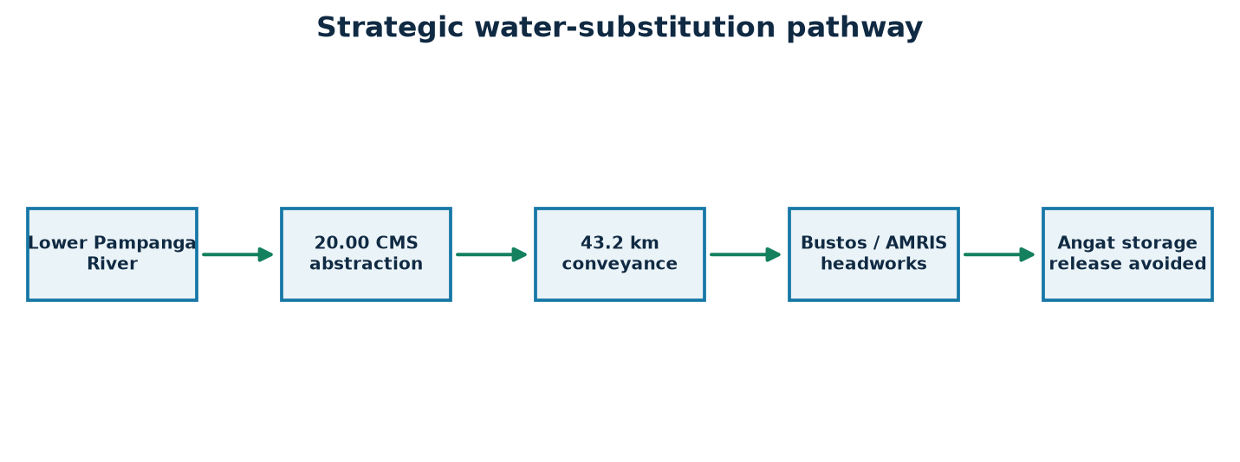
Figure 1-1. Strategic water-substitution pathway
Source: Revision 2 controlled project basis; conceptual and not for construction.

1.2 Project Purpose and Objectives
Controlled feasibility basis · September 2026
The project purpose is to develop a resilient abstraction and conveyance system capable of transferring 20.00 CMS from the lower Pampanga River to the Bustos Dam / AMRIS headworks. Objectives combine water-security outcomes, reliable irrigation service, flood-resilient infrastructure, operable two-stage pumping, and a financeable delivery structure.
The main objective is a reliable 20.00 CMS delivery into the AMRIS canal system at Bustos. Supporting objectives are resilience against the 100-year flood through a platform at El. +10.00 m MSL, energy-efficient pumping in two stages with variable-frequency drives, and a financing structure that can support 70% senior debt at a minimum DSCR of 1.65x.
The objectives pull against each other in a few places. Higher availability means more standby equipment and capital. Flood resilience needs 375,000 m³ of fill and ground treatment. Energy efficiency needs detailed hydraulic optimisation along the 43.2 km corridor. Revision 2 settles these trade-offs at a controlled CAPEX of ₱14,850.00 million.
Each objective should have a measurable acceptance test: delivered flow at the terminal flume, platform elevation certified by survey, specific energy in kWh per m³ against a design target, and lender-model coverage ratios. These tests become the basis for commissioning and contract performance guarantees.
DECISION POINT
Objective hierarchy: water-security service first, resilience second, efficiency third, and financeability as a binding constraint.

Key requirements and decision checks
- Maintain the stated irrigation substitution service
- Provide standby capacity and operational flexibility
- Meet environmental-flow and water-quality constraints
- Deliver auditable cost, schedule, and performance controls

1.3 Objectives and Scope of the Study
Controlled feasibility basis · September 2026
This feasibility study integrates strategic, site, hydrologic, geotechnical, engineering, safeguards, implementation, financial, and economic workstreams. It defines a decision basis rather than detailed design and identifies the investigations and agreements needed to move from concept to bankable development.
The study covers the whole value chain from river abstraction to AMRIS delivery. It spans nine technical chapters and eight annexes. It does not include detailed design drawings, procurement documents, or permit applications. Those follow once the decision gates in Chapter 9 are passed.
The study separates three kinds of information: controlling Revision 2 values (the 16-item CAPEX, package totals, and financial corollaries); derived values calculated from them (billed volume, annual principal, depreciation); and assumptions that still need field verification (hydrology, soil parameters, corridor alignment).
Readers should use the study to decide whether to fund the next development stage, not to approve construction. The scope has been set so that each unresolved matter is linked to a named investigation and a gate.
DECISION POINT
Scope boundary: feasibility and pre-investment decision basis. It is not a detailed design or a permit application.

Key requirements and decision checks
- Define the revised five-hectare physical configuration
- Reconcile the 16-item CAPEX schedule
- Assess material risks and mitigations
- Set clear pre-investment decision gates

1.4 Institutional and Policy Setting
Controlled feasibility basis · September 2026
Implementation requires coordinated decisions across irrigation operations, water allocation, environmental review, local permitting, land access, power supply, and financing. NIA and AMRIS operational requirements are central, while water-rights, environmental, local-government, and corridor approvals remain formal preconditions.
Several agencies share authority. NIA operates AMRIS and would be the natural offtaker or service counterparty. MWSS benefits from Angat storage relief. NWRB issues the water permit for Pampanga River abstraction. DENR administers the Environmental Compliance Certificate. NEDA reviews the economic case where public support or guarantees are involved. San Luis and every LGU along the corridor issue local permits and endorsements.
The main institutional risk is that benefits and obligations fall on different parties. MWSS gains from the stored water while NIA receives the delivered irrigation water. A tripartite or multi-party agreement will probably be needed to align the tariff, payment security, and operating rules with the party that captures each benefit.
An inter-agency technical working group should be formed at the start of the next stage. It needs clear terms of reference, a document register, and an agreed sequence of approvals, so that no permit depends on another one that has not yet been issued.
DECISION POINT
Key counterparties: NIA (offtake), MWSS (storage benefit), NWRB (water rights), DENR (ECC), NEDA (economic review), and the host and corridor LGUs.

Key requirements and decision checks
- Assign a lead project sponsor and accountable delivery office
- Establish an inter-agency technical working group
- Define approval interfaces and documentary evidence
- Separate regulator, offtaker, owner, and independent-review roles

1.5 Study Methodology and Information Hierarchy
Controlled feasibility basis · September 2026
Revision 2 treats the supplied 2026 CAPEX and financial schedules as controlling. The 79-page source study provides contextual and technical reference where it does not conflict, while calculated values are identified as derived and unresolved items remain verification requirements.
The study follows a strict order of evidence. The three supplied Revision 2 schedules override every other source. Values calculated from them come next. The 79-page source study provides context where it does not conflict. Engineering judgement fills any remaining gaps and is always flagged as an assumption.
This order keeps every figure in the report consistent. For example, where the source study gave an earlier ₱11.60 billion CAPEX, this report shows only the ₱14,850.00 million controlled figure and records the difference in Annex A rather than presenting both.
Future revisions should keep the same discipline. Every change to a controlled value needs a revision-register entry, an approving authority, and a check of every table, figure, and narrative reference that depends on it.
DECISION POINT
Evidence order: controlled schedules, then derived values, then source-study context, then flagged engineering assumptions.

Key requirements and decision checks
- Controlled schedules override superseded source figures
- Measured field data should override desktop assumptions after validation
- Design criteria require discipline-lead approval
- Financial outputs require independent model audit

2.1 Project Location and Accessibility
Controlled feasibility basis · September 2026
The source complex is proposed at Barangay Sta. Cruz Pambilog, San Luis, Pampanga, on the lower Pampanga River. Construction access must accommodate heavy pumps, transformers, pipe sections, cranes, fill deliveries, and emergency response without creating unacceptable disruption to local roads and communities.
Barangay Sta. Cruz Pambilog lies on the lower Pampanga River in San Luis, Pampanga, about 43 km by the proposed corridor from the Bustos Dam in Bulacan. Access is expected to come from the municipal road network linking San Luis to the provincial highway system. Final routes for heavy loads depend on bridge and road-capacity surveys.
The heaviest deliveries are the two 25 MVA power transformers, the high-lift pump casings, and large-diameter steel pipe sections. Transport studies must check bridge load ratings, turning radii, overhead clearances, and wet-season road condition. Fill haulage of about 375,000 m³ will also create sustained truck traffic, which needs a community traffic-management plan.
Before the site is frozen, the team should confirm permanent all-weather access that remains usable during a design flood. This matters because the operations zone and substation must stay reachable while the surrounding floodplain is under water.
KEY FINDING
Access priority: an all-weather, flood-passable route for operations staff, emergency response, and heavy equipment replacement.

Key requirements and decision checks
- Complete topographic and cadastral control
- Confirm all-weather construction access and bridge capacities
- Plan abnormal-load routes for transformers and pump equipment
- Preserve emergency and community access

2.2 Existing Physical Features
Controlled feasibility basis · September 2026
The working site concept occupies approximately 250 m of river frontage by 200 m depth. Riverbank condition, drainage paths, agricultural use, utilities, structures, access tracks, and seasonal inundation must be mapped before the arrangement is frozen.
The site is expected to be mainly agricultural floodplain with river frontage of about 250 m. The riverbank may show seasonal erosion. Informal access tracks, irrigation ditches, and scattered structures may be present. These conditions are assumed from the source study and satellite interpretation and have not yet been surveyed.
The riverbank's current condition directly affects the intake design and the Class B riprap revetment within the ₱135.00 million polder and revetment allocation. Active bank retreat would require a longer revetment, deeper toe protection, or moving the intake upstream or downstream.
A baseline survey package should record topography, bathymetry of the intake reach, existing structures, vegetation, drainage outfalls, and utilities, with photographs and dated condition notes. This baseline also serves as evidence for safeguards and compensation.
DECISION POINT
Survey dependency: intake position and revetment length cannot be frozen until the riverbank and intake-reach bathymetry are surveyed.

Key requirements and decision checks
- Survey riverbank geometry and erosion indicators
- Map utilities, structures, vegetation, and drainage outfalls
- Record existing land use and access rights
- Establish photographic and condition baselines

2.3 Topography, Drainage and Flood Setting
Controlled feasibility basis · September 2026
The site is a low-lying floodplain location with natural grade at about El. +4.00 m MSL and a stated 100-year flood level of El. +9.00 m MSL. Site formation, polder protection, internal drainage, retention, and emergency pumping therefore operate as one resilience system.
Natural grade is about El. +4.00 m MSL. The 100-year flood reaches El. +9.00 m MSL, so the site would sit under up to 5 m of water in a design flood without intervention. The response combines three measures: raising the operating platform by 6.0 m to El. +10.00 m MSL, surrounding it with a 0.90 km polder ring dike with crest at El. +10.50 m MSL, and providing internal drainage to a 15,000 m³ retention pond with 2 × 1.5 CMS emergency pumps.
Flood resilience also means managing rain that falls inside the polder when the river is high and gravity outfalls are closed. The retention pond and pumps are sized for this situation, but the sizing must be confirmed by combined modelling of river levels and local rainfall.
All levels must be tied to a single approved vertical datum. A datum mismatch of even 0.3 m would take up a third of the design freeboard, so survey control is a critical first action.
DECISION POINT
Resilience system: +6.0 m platform raise, El. +10.50 m polder crest, and internal retention with emergency pumping, working together.

Key requirements and decision checks
- Tie surveys to an approved vertical datum
- Model external flood levels and internal rainfall jointly
- Protect gravity and pumped drainage discharge points
- Provide maintainable inspection access around the polder

2.4 Climate and Seasonal Conditions
Controlled feasibility basis · September 2026
Monsoon rainfall, typhoon exposure, prolonged wet-season saturation, and dry-season river conditions influence construction productivity and long-term operation. Seasonal planning should distinguish high-flow flood risk from low-flow abstraction reliability and salinity risk.
Central Luzon has a Type I climate: a pronounced dry season from about November to April and a wet season from May to October dominated by the southwest monsoon and typhoons. Most annual rainfall falls between June and September, when the lower Pampanga floodplain regularly floods.
Seasonality shapes both construction and operation. Earthworks, ground treatment, and trenching are most productive in the dry season, so the 36-month programme puts enabling works and fill placement in dry windows. In operation, the dry season is when AMRIS demand and Angat stress peak, and also when the river's low flow and salinity must be checked.
The construction programme should include weather allowances, and the contract should define compensable weather events. Operating rules should state how abstraction is adjusted if dry-season river conditions fall below the environmental-flow threshold.
DECISION POINT
Seasonal tension: peak irrigation need and lowest river flow coincide in the dry season, so source reliability is the critical check.

Key requirements and decision checks
- Use current rainfall intensity-duration-frequency data
- Allow for typhoon shutdown and recovery procedures
- Sequence earthworks around wet-season constraints
- Apply climate-change allowances during detailed design

2.5 Existing Irrigation System and Service Area
Controlled feasibility basis · September 2026
The receiving interface is the Bustos Dam / AMRIS headworks, where transferred water must be measured, dissipated, and introduced without impairing canal operations. The delivery regime must match irrigation scheduling, canal capacity, maintenance outages, and agreed water-accounting rules.
AMRIS takes water at the Bustos Dam and distributes it through a canal network serving irrigated rice land across Bulacan. Its supply has historically depended on Angat releases passing through the Ipo and Bustos structures. The project connects at the Bustos terminal through an energy-dissipation basin and a measuring flume.
The terminal works (₱320.00 million) must deliver the water at a level and flow rate that suit existing AMRIS canal hydraulics without causing scour or disrupting downstream turnouts. Operating coordination with NIA is needed so that project deliveries and any remaining Angat releases are scheduled together.
NIA should confirm canal capacity, command levels, rotation schedules, and seasonal demand patterns at Bustos. These define how the 20.00 CMS is actually used and whether the terminal needs additional flow-control structures.
DECISION POINT
Interface point: Bustos Dam / AMRIS headworks, where delivered flow is metered and the substitution volume is recorded.

Key requirements and decision checks
- Confirm seasonal and daily AMRIS demand profiles
- Define custody-transfer metering and data ownership
- Coordinate terminal shutdown windows
- Prepare transition and fallback operating procedures

2.6 Five-Hectare Site Allocation
Controlled feasibility basis · September 2026
The compact 5.00 ha arrangement divides the process into five functional zones, separating wet-process assets, high-energy equipment, flood storage, and operational support. Final layout must maintain hydraulic efficiency while providing safe circulation, lifting access, fire separation, drainage, and future maintenance space.
The 5.0 ha complex is divided into five zones arranged in process order from the river frontage inward. Zone 1 (1.0 ha) holds the intake and low-lift pumps next to the river. Zone 2 (1.5 ha) holds the vortex desanders and the 60,000 m³ forebay. Zone 3 (1.2 ha) holds the high-lift pump hall and the 69 kV switchyard. Zone 4 (0.8 ha) holds stormwater retention and polder facilities. Zone 5 (0.5 ha) holds administration, SCADA, the laboratory, and access.
Land is acquired at a verified ₱500/m², giving ₱25.00 million for 50,000 m². Placing the heavy structures in Zones 1 and 3 over the 15,000 m² stone-column area, with general yard over the 35,000 m² PVD area, links the site plan to the ground-treatment strategy.
The layout should be tested for crane access, equipment replacement paths, fire separation between the transformer and the pump hall, and room for future expansion. The allocation is conceptual and not for construction.
DECISION POINT
Allocation: 1.0 + 1.5 + 1.2 + 0.8 + 0.5 ha = 5.0 ha, arranged in process order from the river inward.

Key requirements and decision checks
- Protect direct hydraulic paths between process stages
- Separate public, operational, and heavy-maintenance traffic
- Reserve crane and equipment-removal corridors
- Maintain flood-safe access to controls and emergency systems
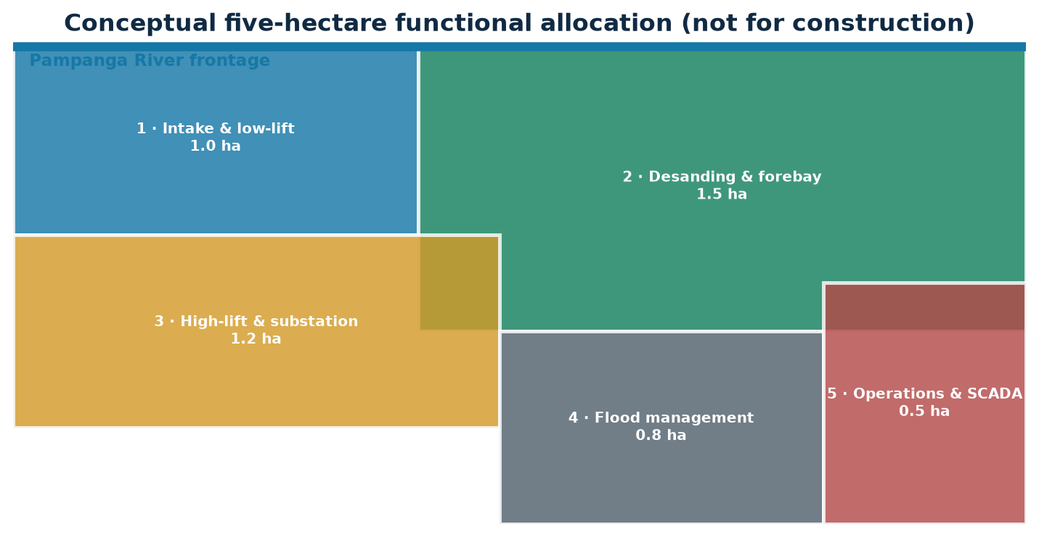
Figure 2-1. Conceptual five-hectare functional allocation
Source: Revision 2 controlled project basis; conceptual and not for construction.
Zone | Area | Primary function
1 | 1.0 ha | River intake and low-lift pumping
2 | 1.5 ha | Vortex desanding and 60,000 m³ forebay
3 | 1.2 ha | High-lift pumping and 69 kV substation
4 | 0.8 ha | Stormwater storage and polder systems
5 | 0.5 ha | Administration, SCADA, laboratory and access

2.7 Conveyance Corridor and Rights-of-Way
Controlled feasibility basis · September 2026
The 43.2 km twin-barrel corridor is the largest physical and cost component. Route selection must balance hydraulic grade, constructability, property impacts, road and waterway crossings, utility conflicts, geohazards, valve access, and long-term security of tenure.
The 43.2 km twin-barrel steel pipeline is the largest single cost item at ₱7,850.00 million, or 52.86% of CAPEX. The route crosses agricultural land, municipal roads, national highways, irrigation canals, creeks, and possibly rail or major utility corridors between San Luis and Bustos.
Crossings under major waterways and highways are expected to use horizontal directional drilling, as allowed for in the CAPEX basis. The route also needs permanent easements, access at valves and chambers, cathodic-protection test points, and drainage outfalls. The safeguards and ROW allocation of ₱125.00 million covers easement acquisition and crop compensation.
Corridor control is a gating risk. Parcel-by-parcel cadastral verification, utility locating, and early stakeholder engagement should start in the next stage so the route can be fixed before detailed hydraulic design and pipe procurement.
DECISION POINT
Cost concentration: the 43.2 km corridor is 52.86% of CAPEX, so route certainty has the largest effect on cost and schedule.

Key requirements and decision checks
- Complete parcel-by-parcel cadastral mapping
- Develop a crossing and utility-conflict register
- Compare open-cut and trenchless construction reaches
- Secure permanent access at valves and protection facilities
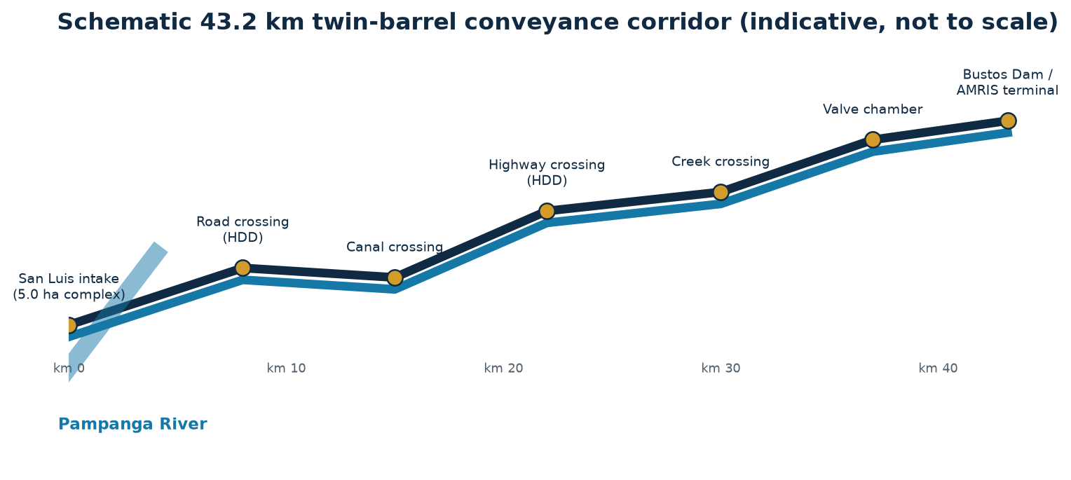
Figure 2-2. Schematic 43.2 km conveyance corridor
Source: Revision 2 controlled project basis; conceptual and not for construction.

3.1 Available Water and Source Reliability
Controlled feasibility basis · September 2026
A nominal 20.00 CMS abstraction is feasible only if the lower Pampanga River can sustain the withdrawal under seasonal low-flow conditions while honoring environmental and downstream-use constraints. Reliability must be demonstrated through observed records and basin water-balance analysis, not annual averages alone.
The lower Pampanga River drains a basin of about 10,000 km² including the Pampanga, Rio Chico, and Angat sub-basins. Its average flow is well above 20.00 CMS for most of the year. The binding question is dry-season reliability, when flows fall and other users, including existing irrigation diversions and environmental needs, compete for the same water.
Taking 20.00 CMS reliably requires the dry-season flow at the intake to exceed the abstraction plus the environmental flow plus the needs of downstream users, at the target exceedance probability. If that margin is thin, the operating rule may need seasonal abstraction reductions, which would affect the 95% availability assumption.
A flow-duration analysis using long-term gauging records, adjusted to the intake site, is the first hydrologic deliverable. Without it, the revenue assumption of 599.18 million m³ billed per year cannot be relied on for lending.
KEY FINDING
Reliability test: dry-season flow must exceed 20.00 CMS plus environmental flow plus downstream rights at the design exceedance level.

Key requirements and decision checks
- Compile and quality-check daily flow records
- Develop dependable-flow curves by month
- Account for upstream regulation and competing withdrawals
- Test drought and climate-adjusted sequences

3.2 Climate and Rainfall Information
Controlled feasibility basis · September 2026
Rainfall controls both flood loading and the seasonal replenishment supporting abstraction. Basin-wide rainfall analysis should distinguish event intensity for drainage design from cumulative and antecedent rainfall relevant to river yield and sediment mobilization.
Average annual rainfall across the Pampanga basin is roughly 2,000–2,500 mm, and most of it falls in the wet season. Typhoons can deliver several hundred millimetres in a few days, causing the floods that set the El. +9.00 m MSL design level.
Rainfall affects three separate design questions: river flood levels for the platform and polder, local storm intensity for internal drainage and the retention pond, and dry-season deficits for source reliability. Each needs a different statistical treatment and design return period.
Rainfall analysis should use PAGASA station data, with a documented treatment of missing records and a climate-change allowance consistent with national guidance.
DECISION POINT
Three uses: flood levels, internal drainage intensity, and dry-season yield, each needing its own statistical treatment.

Key requirements and decision checks
- Update station inventory and record completeness
- Derive design-storm inputs for site drainage
- Assess non-stationarity and climate allowances
- Relate rainfall regimes to source reliability

3.3 Meteorological Data Review
Controlled feasibility basis · September 2026
Temperature, humidity, wind, evaporation, and extreme-weather conditions affect equipment selection, electrical enclosures, worker safety, water losses, and emergency readiness. The design basis should reference representative stations and document gaps in local records.
Meteorological inputs include temperature, humidity, wind, and evaporation as well as rainfall. They affect crop water demand in AMRIS, evaporation from the forebay and retention pond, and the operating environment for electrical equipment.
Evaporation losses from the 60,000 m³ forebay are small compared with the 1.728 million m³/day throughput, but crop evapotranspiration drives AMRIS demand and therefore the seasonal pattern of the substitution service. Typhoon wind speeds also govern the structural design of pump houses and the substation.
Data should be taken from the nearest PAGASA synoptic stations, with gaps and station changes documented, and the resulting design values recorded in the design-basis register.
DECISION POINT
Design relevance: crop demand, wind loading on structures, and the thermal environment for equipment.

Key requirements and decision checks
- Confirm design temperature and humidity envelopes
- Specify wind and typhoon design criteria
- Assess evaporation from the forebay
- Define lightning and surge-protection exposure

3.4 AMRIS Water Demand and Substitution Logic
Controlled feasibility basis · September 2026
The scheme is justified by replacing AMRIS irrigation supply otherwise released from Angat, not by increasing irrigation entitlement. An auditable operating protocol should link transferred volume, measured AMRIS delivery, and the corresponding avoided Angat release.
AMRIS demand varies with the cropping calendar, peaking during land preparation and early crop growth in both wet- and dry-season plantings. The project delivers a steady 20.00 CMS, which replaces an equal Angat release when demand is at or above that level.
The substitution logic rests on an accounting principle: each cubic metre delivered to AMRIS from the project is one cubic metre that Angat does not have to release. For this to hold, NIA and NWRB must reduce the Angat irrigation allocation by the delivered volume, and the resulting storage gain must be available to MWSS.
The water-accounting protocol should state the measurement point, metering standards, reconciliation period, and treatment of periods when AMRIS demand is below 20.00 CMS. Those periods could reduce billed volume unless the offtake agreement specifies take-or-pay terms.
DECISION POINT
Accounting principle: one cubic metre delivered from the project replaces one cubic metre of Angat release.

Key requirements and decision checks
- Define baseline irrigation demand and allocation rules
- Agree measurement points and reconciliation periods
- Address seasonal mismatch between source and demand
- Specify curtailment priorities during constrained conditions

3.5 Design Flow and Operating Availability
Controlled feasibility basis · September 2026
At 20.00 m³/s, nominal annual transfer is 630.72 million m³; applying 95% availability gives 599.18 million m³ of billed volume. Availability must encompass planned maintenance, forced outages, source constraints, power interruptions, and terminal restrictions.
The design flow is 20.00 m³/s, or 1.728 million m³/day and 630.72 million m³/year. At 95% availability the billed volume is 599.18 million m³, which is the basis of the ₱8,688.17 million Year 1 revenue at ₱14.50/m³.
Each stage has nine 2.5 CMS pumps, with eight on duty delivering 20.00 CMS and one on standby. Losing one pump therefore does not reduce output. The 5% unavailability allowance covers planned maintenance windows, power outages, source restrictions, and major repairs.
Availability should be modelled from equipment reliability data, grid outage statistics, and hydrologic restriction frequency rather than assumed. This analysis supports the performance guarantees in the offtake agreement.
DECISION POINT
Availability basis: 95% × 630.72 million m³ = 599.18 million m³ billed each year.

Key requirements and decision checks
- Allocate outage allowances by system component
- Demonstrate N+1 pumping availability
- Coordinate planned outages with irrigation schedules
- Stress-test combined source and equipment outages

3.6 Flood Levels and Freeboard
Controlled feasibility basis · September 2026
The stated elevation basis raises the operating platform from El. +4.00 m to El. +10.00 m MSL, one metre above the El. +9.00 m 100-year flood level. The perimeter dike crest at El. +10.50 m adds protection but requires verification for settlement, wave action, uncertainty, and climate change.
The site levels are natural grade El. +4.00 m MSL, 100-year flood El. +9.00 m MSL, platform El. +10.00 m MSL, and polder crest El. +10.50 m MSL. This gives 1.00 m of freeboard from flood to platform and a further 0.50 m to the dike crest.
Freeboard covers wave run-up, uncertainty in the flood estimate, settlement of fill and dike, and climate-change allowance. If detailed modelling raises the design flood or settlement exceeds predictions, the freeboard shrinks. This makes the ground-treatment performance in Chapter 4 directly relevant to flood safety.
Hydraulic modelling of the lower Pampanga reach should confirm the design flood level, flow velocities for scour design, and the effect of the raised platform on upstream and neighbouring flood levels.
DECISION POINT
Freeboard: 1.00 m from the 100-year flood to the platform, and 1.50 m to the polder crest.

Key requirements and decision checks
- Confirm datum consistency and flood-frequency method
- Check local scour and riverbank stability
- Include settlement allowance in final crest levels
- Provide safe exceedance and emergency-pumping procedures
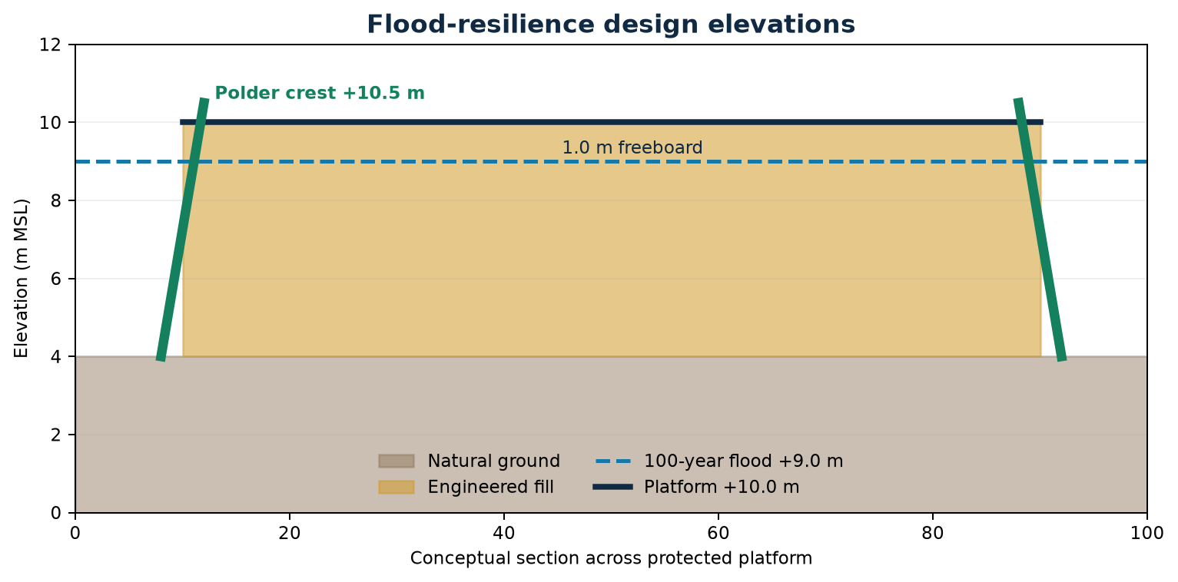
Figure 3-1. Flood-resilience design elevations
Source: Revision 2 controlled project basis; conceptual and not for construction.
Element | Elevation / extent
Natural site grade | El. +4.00 m MSL
100-year design flood | El. +9.00 m MSL
Operating platform | El. +10.00 m MSL
Platform freeboard | 1.00 m
Polder crest | El. +10.50 m MSL
Polder perimeter | 0.90 km

3.7 Sediment, Salinity and Water Quality
Controlled feasibility basis · September 2026
Lower-river operation may encounter high suspended sediment during floods, salinity migration during low flow, debris, and variable raw-water quality. These conditions affect pump wear, desander loading, disposal requirements, and the allowable abstraction window.
Lower Pampanga water carries a significant suspended sediment load, especially in the wet season, and sand that would wear pump impellers. The site is also close enough to Manila Bay that saline intrusion during very low river flow must be checked.
Sediment is handled in stages: coarse screens at the intake, two-cell vortex desanders after the low-lift stage, and settling in the forebay. The high-lift pumps and the 43.2 km pipeline then carry cleaner water, which lowers wear and deposition. Salinity above irrigation tolerance would require temporary abstraction limits.
A water-quality sampling programme covering at least one full hydrologic year is needed, measuring suspended sediment, sand fraction, salinity, and agricultural and industrial contaminants.
DECISION POINT
Treatment chain: screens, then vortex desanding, then forebay settling, to protect the high-lift pumps and pipeline.

Key requirements and decision checks
- Undertake seasonal depth-profile sampling
- Define salinity and turbidity operating thresholds
- Characterize sediment particle-size distribution
- Prepare lawful sediment handling and disposal routes

3.8 Hydrologic Verification Program
Controlled feasibility basis · September 2026
A bankable verification program should convert the current feasibility assumptions into an approved abstraction rule. It should combine gauging, water-level records, water-quality monitoring, basin modelling, environmental-flow assessment, and independent review across representative seasons.
The verification programme turns the hydrologic assumptions into bankable evidence. It covers streamflow gauging at or near the intake, flow-duration and low-flow frequency analysis, flood-frequency analysis, hydraulic modelling of the reach, sediment and salinity sampling, and an environmental-flow assessment.
The programme should begin as early as possible because it needs at least one full dry season and ideally a full year of site data. Its results feed the water-permit application, intake design, availability model, and lender technical due diligence.
Gate 1 in Chapter 9 depends entirely on this programme. A shortfall found here would change the project scale or operating rules before larger development costs are committed.
DECISION POINT
Critical path: at least one full dry season of site gauging and sampling is needed before Gate 1 can close.

Key requirements and decision checks
- Install and maintain calibrated monitoring stations
- Collect at least representative wet- and dry-season evidence
- Document model calibration and uncertainty
- Submit the operating rule for institutional approval

4.1 Geological Environment
Controlled feasibility basis · September 2026
The site lies within a young deltaic and alluvial setting where soft, compressible soils are credible. The working model of 8.5–12 m of soft silty clay explains the emphasis on staged fill, drainage, and foundation improvement, but must be confirmed spatially.
The lower Pampanga floodplain is made of recent deltaic and alluvial deposits: soft to very soft silty clays, clayey silts, and loose sands over stiffer Pleistocene layers. The working model assumes about 8.5–12 m of soft silty clay beneath the site.
Soft clay under 6 m of new fill will consolidate significantly, possibly by several hundred millimetres or more without treatment. Heavy pump and transformer foundations need controlled differential settlement to protect alignment and piping connections.
The geological model should be confirmed by boreholes and CPTu soundings before the ground-treatment layout and fill sequence are finalised.
KEY FINDING
Working model: 8.5–12 m of soft deltaic silty clay, which drives the PVD and stone-column strategy.

Key requirements and decision checks
- Develop an engineering-geology and geomorphology model
- Map old channels, fills, and weak zones
- Screen liquefaction and lateral-spreading susceptibility
- Tie subsurface interpretation to structure locations
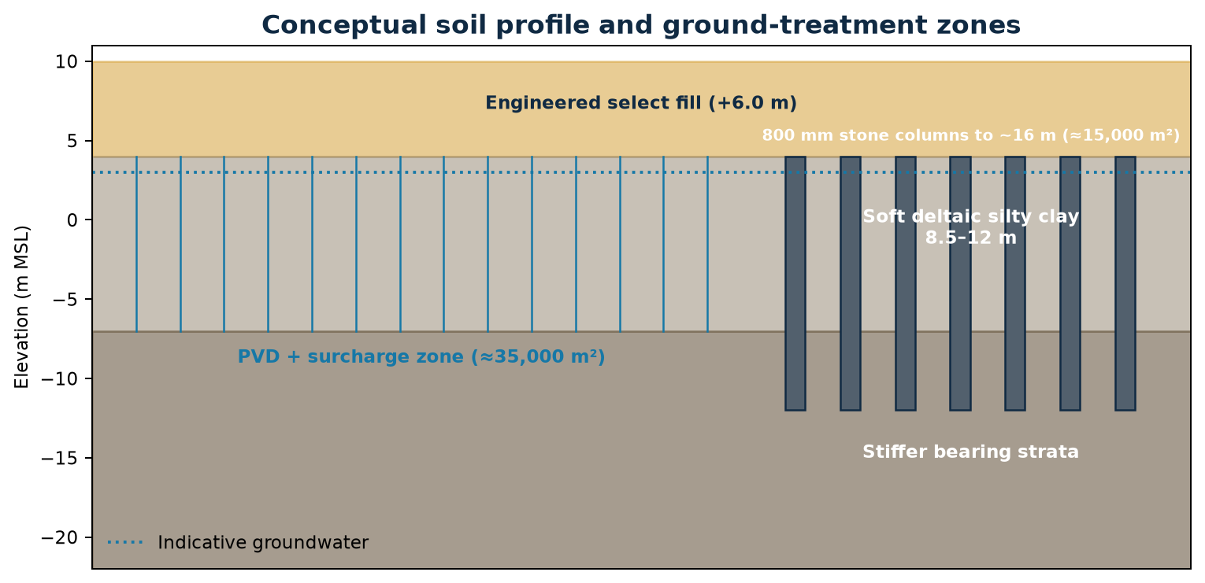
Figure 4-1. Conceptual soil profile and ground-treatment zones
Source: Revision 2 controlled project basis; conceptual and not for construction.

4.2 Investigation Methodology
Controlled feasibility basis · September 2026
Investigation should be risk-based: closer spacing beneath pump halls, forebay walls, substation foundations, dikes, and critical pipeline crossings, with broader coverage across general yards. Methods should combine boreholes, CPTu, geophysics where useful, and groundwater monitoring.
The proposed investigation combines boreholes with standard penetration testing and undisturbed sampling, piezocone (CPTu) soundings with dissipation tests, groundwater observation wells, and laboratory testing. Coverage should be denser beneath the Zone 1 and Zone 3 heavy structures and along the polder alignment.
Along the 43.2 km corridor, a lighter programme of boreholes and test pits at regular spacing and at every major crossing will define trench stability, pipe bedding, groundwater control, and HDD conditions.
The investigation is funded within the ₱650.00 million EPCM allowance. It should be specified by the geotechnical lead and reviewed independently before tendering.
DECISION POINT
Method: boreholes, CPTu, groundwater monitoring, and laboratory testing, concentrated beneath the heavy structures.

Key requirements and decision checks
- Prepare a discipline-approved investigation plan
- Use staged investigation as layout decisions mature
- Define sampling quality and laboratory standards
- Maintain auditable coordinates, levels, and logs

4.3 Drilling, Sampling and Laboratory Testing
Controlled feasibility basis · September 2026
The test program must characterize strength, compressibility, permeability, cyclic response, and aggressivity. High-quality undisturbed samples are particularly important for consolidation design, while CPTu provides continuous stratigraphic resolution between boreholes.
Boreholes should reach through the soft clay into competent bearing strata, which is expected to be at least 20–25 m under the heavy structures. Thin-walled tube samples of the clay are needed for consolidation (oedometer), triaxial, index, and organic-content testing.
The laboratory results give the parameters for settlement and stability analysis: compression index, coefficient of consolidation, preconsolidation pressure, and undrained shear strength. These determine PVD spacing, surcharge height and duration, stone-column spacing, and staged-fill rates.
Sample quality must be controlled carefully, because disturbed soft-clay samples underestimate strength and misrepresent compressibility.
DECISION POINT
Key parameters: compression index, coefficient of consolidation, preconsolidation pressure, and undrained shear strength.

Key requirements and decision checks
- Perform index, strength, and consolidation testing
- Measure groundwater and pore-pressure response
- Test fill and stone-column materials
- Apply independent data validation and geotechnical interpretive reporting

4.4 Groundwater and Consolidation Conditions
Controlled feasibility basis · September 2026
High groundwater and soft clay can drive slow consolidation, basal instability, and lateral deformation under the six-metre platform raise. Design must predict staged settlement and pore-pressure dissipation, then verify performance through instrumentation.
Groundwater is expected close to the surface and to vary seasonally with river level. A high water table plus low-permeability clay means consolidation under the new fill would take many years without drainage treatment.
Excess pore pressure generated by fast filling also lowers the clay's short-term stability, which could cause embankment or dike failure. Fill must therefore be placed in stages with measured pore-pressure dissipation between lifts.
Piezometers, settlement plates, and inclinometers should be installed before filling starts and read throughout construction. These readings form the observational basis for approving each fill stage.
DECISION POINT
Control principle: place fill in stages, releasing each lift only after measured pore pressure has dissipated.

Key requirements and decision checks
- Model primary and secondary consolidation
- Check staged embankment stability
- Set settlement and pore-pressure hold points
- Protect nearby properties and utilities from drawdown or movement

4.5 PVD and Surcharge Treatment
Controlled feasibility basis · September 2026
Approximately 35,000 m² of general yard is assigned to prefabricated vertical drains and surcharge preloading. Drain spacing, pattern, depth, surcharge height, dwell period, drainage blanket, and acceptance criteria should be optimized against the construction schedule.
Prefabricated vertical drains with surcharge treat about 35,000 m² of general yard. The drains shorten the drainage path in the clay, so consolidation that would take decades finishes within months. A temporary surcharge above final platform level preloads the ground so later settlement stays within tolerance.
Drain spacing, surcharge height, and hold time will be set from laboratory parameters and checked with a trial embankment. Surcharge removal is triggered when monitored settlement rates fall below the agreed threshold.
PVD treatment is part of Item 3 (₱185.00 million). The programme allows for this treatment during enabling works in months 1–10.
DECISION POINT
Treatment area: about 35,000 m² of PVD with surcharge beneath the general yard and forebay embankments.

Key requirements and decision checks
- Complete trial embankment and wick-drain trials
- Instrument settlement plates and piezometers
- Define residual-settlement limits by asset type
- Retain surcharge until verified performance criteria are met

4.6 Stone-Column Treatment
Controlled feasibility basis · September 2026
Heavy and dynamic structures across about 15,000 m² use 800 mm vibro-replacement stone columns extending to approximately 16 m. Detailed design must verify replacement ratio, load transfer, group behavior, drainage benefit, vibration effects, and compatibility with structural foundations.
About 15,000 m² beneath the heavy and dynamic structures, the pump halls, desanders, and substation, is treated with 800 mm diameter vibro-replacement stone columns to about 16 m depth. The columns stiffen the ground, speed up drainage, and reduce total and differential settlement under concentrated loads.
Stone columns work best in clay with enough strength to confine the column. Very soft layers found in investigation could require closer spacing, bottom-feed methods, or a switch to piled foundations for the most sensitive equipment.
Load tests on trial columns and settlement monitoring under early structures should confirm performance before the main pump foundations are cast.
DECISION POINT
Heavy structures: 800 mm stone columns to about 16 m over about 15,000 m² beneath the pump halls and substation.

Key requirements and decision checks
- Conduct installation and load trials
- Verify column continuity and diameter
- Assess liquefaction and cyclic performance
- Coordinate column grids with foundations and buried services

4.7 Geotechnical Conclusions and Verification
Controlled feasibility basis · September 2026
The proposed treatment concept is technically plausible but remains investigation-dependent. Final acceptance should be based on observed performance, not method completion alone, with explicit thresholds for settlement, lateral movement, pore pressure, bearing response, and vibration.
The geotechnical strategy is technically suitable for the assumed conditions and is fully funded within Item 3. Its success depends on how well the actual ground matches the working model and on disciplined, observation-based construction.
The main residual risks are thicker or softer clay than assumed, organic layers, a longer consolidation period, and higher-than-predicted differential settlement. Each would affect cost, schedule, or flood freeboard.
Gate 2 should require a completed investigation report, a confirmed design, trial-embankment results, and an instrumentation plan with numerical acceptance thresholds.
DECISION POINT
Conclusion: suitable in principle, subject to confirmation by investigation and trial embankment before Gate 2.

Key requirements and decision checks
- Close critical data gaps before detailed design freeze
- Use observational-method trigger levels
- Assign instrumentation ownership and reporting
- Maintain a geotechnical risk register through construction

5.1 Development Concept and Design Criteria
Controlled feasibility basis · September 2026
The engineering concept combines resilience, redundancy, maintainability, and staged hydraulic control within a compact five-hectare site. Design criteria should be consolidated into a controlled register covering flows, levels, pressures, materials, standby philosophy, access, safety, and service life.
Water passes through six steps: a screened river intake, low-lift pumping, vortex desanding, the balancing forebay, high-lift pumping, and twin-barrel conveyance to Bustos. Splitting the pumping into two stages lets the low-lift pumps handle a variable river level and raw water, while the high-lift pumps work from a stable forebay level with desanded water.
The main design criteria are 20.00 CMS delivered, N+1 standby in each stage, VFD control, a platform at El. +10.00 m MSL, ground treatment to settlement tolerance, surge protection for the 43.2 km pipeline, and SCADA monitoring throughout.
The design criteria document should be approved by every discipline lead before detailed design and kept under revision control through construction.
KEY FINDING
Process: intake, then low-lift, desanding, forebay, high-lift, and 43.2 km conveyance to AMRIS.

Key requirements and decision checks
- Design for 20.00 CMS with one pump unavailable per stage
- Provide safe isolation and bypass logic
- Protect critical controls above flood level
- Allow maintainable equipment removal and replacement
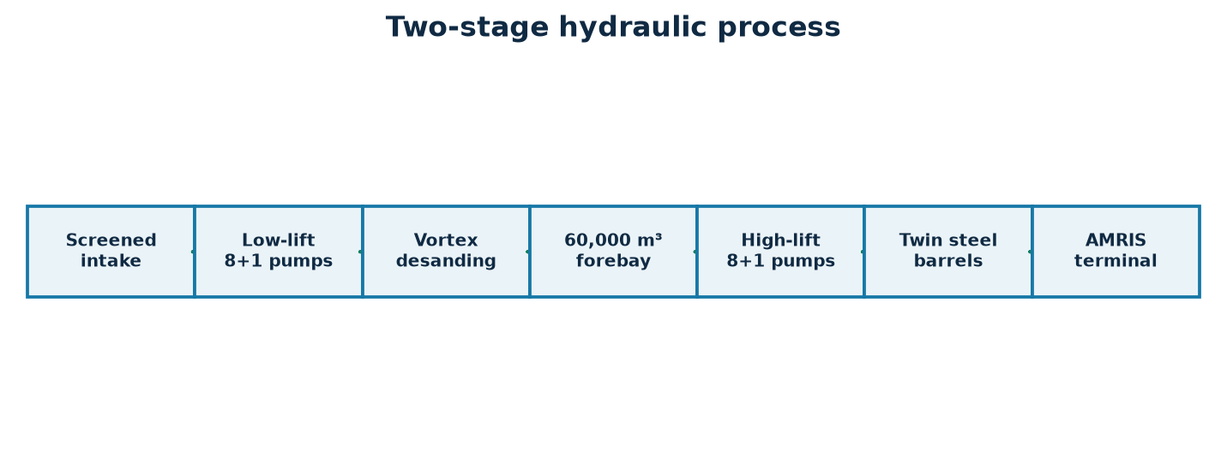
Figure 5-1. Two-stage hydraulic process
Source: Revision 2 controlled project basis; conceptual and not for construction.

5.2 River Intake and Screening
Controlled feasibility basis · September 2026
The intake must admit the design flow across seasonal river levels while limiting debris, sediment, aquatic-organism entrainment, vortices, and localized bank erosion. Multiple bays and isolatable screens support maintenance without complete shutdown.
The intake draws river water through bar screens and dual travelling screens that remove debris and floating material. Its sill must stay submerged at the lowest design river level, and it must withstand flood velocities and debris impact up to the 100-year event.
Water hyacinth, flood debris, and sediment are the main operating hazards. The dual-screen arrangement allows cleaning one screen while the other stays in service, and automatic cleaning is triggered by head loss across the screens.
Intake position, sill level, and approach-channel design need bathymetric survey and hydraulic modelling, and possibly a physical model for the most critical reach.
DECISION POINT
Design constraint: submerged at minimum river level and robust at the 100-year flood.

Key requirements and decision checks
- Verify approach velocity and submergence
- Select bar spacing and screen-cleaning duty
- Model river training and local scour
- Provide debris handling and safe maintenance access

5.3 Low-Lift Pump Station
Controlled feasibility basis · September 2026
Stage 1 uses nine vertical turbine pumps, eight duty plus one standby, each rated 2.5 CMS at 7.5 m TDH with 250 kW VFD motors. Pump selection should maintain efficiency over seasonal river levels and partial-flow operation.
Stage 1 uses nine vertical turbine pumps, eight on duty and one on standby, each rated 2.5 CMS at 7.5 m total dynamic head with 250 kW VFD motors. Vertical turbines suit a wet-well intake where the river level varies significantly.
Low head keeps Stage 1 power demand modest, at about 2 MW for eight duty units. VFDs let the pumps follow river-level changes while holding the forebay level steady. The raw water carries sand, so impeller materials must be wear-resistant.
Wet-well geometry should follow Hydraulic Institute intake design standards and be checked for vortexing and uneven approach flow.
DECISION POINT
Stage 1: 9 × 2.5 CMS, 7.5 m TDH, 250 kW VFD, 8 duty + 1 standby.

Key requirements and decision checks
- Confirm system curve and operating envelope
- Check intake submergence and cavitation margin
- Define duty rotation and standby testing
- Provide lifting, isolation, and condition-monitoring systems
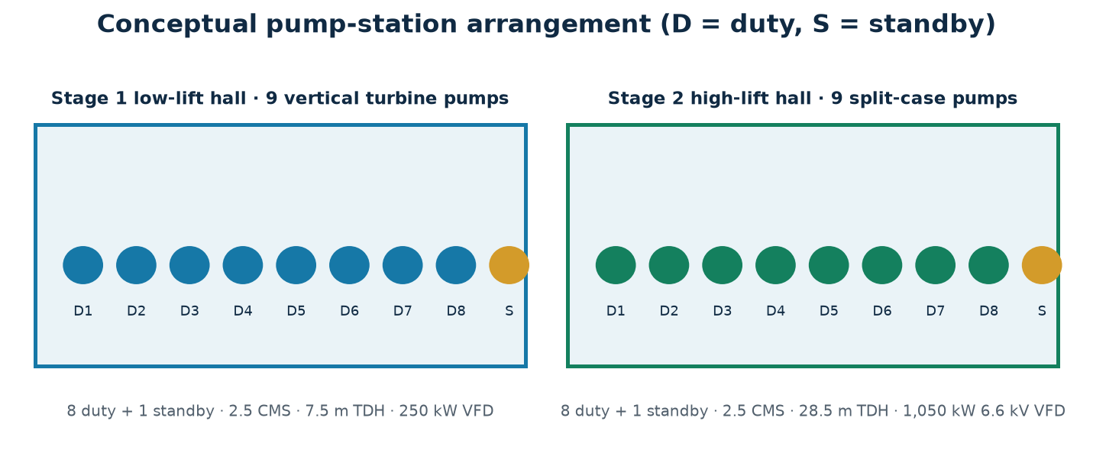
Figure 5-2. Conceptual pump-station arrangement
Source: Revision 2 controlled project basis; conceptual and not for construction.
Stage | Pump arrangement | TDH | Motor
Stage 1 | 9 × 2.5 CMS; 8 duty + 1 standby | 7.5 m | 250 kW VFD
Stage 2 | 9 × 2.5 CMS; 8 duty + 1 standby | 28.5 m | 1,050 kW, 6.6 kV VFD

5.4 Vortex Desanding and Sediment Handling
Controlled feasibility basis · September 2026
Two vortex desanding cells protect downstream pumps and the long pipeline from abrasive sediment. Performance depends on particle-size distribution, hydraulic residence, controlled extraction, wash-water demand, and a practicable route for dewatering and disposal.
Two vortex desanding cells take the Stage 1 discharge and remove sand before the water reaches the forebay and high-lift pumps. Settled sand is pumped or flushed to a dewatering area and removed from site.
Removing sand greatly extends high-lift impeller life and reduces deposition in the pipeline. Having two cells allows one to be taken out for maintenance while the other stays in service, with reduced efficiency accepted.
Desander sizing depends on the sediment grading and concentration measured in the water-quality programme. Disposal of the removed sediment must be covered in the environmental management plan.
DECISION POINT
Function: protect the high-lift pumps and pipeline from abrasive sand.

Key requirements and decision checks
- Set target removable particle size
- Provide one-cell-out-of-service operation
- Automate purge based on loading indicators
- Confirm disposal permits and receiving locations

5.5 Balancing Forebay
Controlled feasibility basis · September 2026
The 60,000 m³ forebay decouples the two pumping stages, absorbs short operational mismatches, and supports controlled restart. Geometry must limit short-circuiting, dead zones, sediment deposition, unsafe slopes, and water-quality deterioration.
The 60,000 m³ forebay separates the two pumping stages. At 20.00 CMS it holds about 50 minutes of flow, which is enough to ride through short Stage 1 interruptions, allow pump changeovers, and dampen control changes.
The forebay is built from reinforced concrete and geomembrane-lined sections on PVD-treated ground (Item 7, ₱420.00 million). It also acts as a final settling basin for fine sediment.
Lining integrity, embankment stability, and sediment removal access should be covered in the detailed design. A split-cell layout would allow maintenance without a full shutdown.
DECISION POINT
Buffer: 60,000 m³, about 50 minutes at 20.00 CMS.

Key requirements and decision checks
- Model residence time and hydraulic mixing
- Provide level bands and emergency storage logic
- Design isolation, drainage, and cleaning access
- Coordinate lining and uplift protection with groundwater

5.6 High-Lift Pump Station
Controlled feasibility basis · September 2026
Stage 2 uses nine horizontal split-case double-suction pumps, eight duty plus one standby, each rated 2.5 CMS at 28.5 m TDH with 1,050 kW, 6.6 kV VFD motors. The station must operate efficiently across pipeline configurations and terminal levels.
Stage 2 uses nine horizontal split-case double-suction pumps, eight on duty and one on standby, each 2.5 CMS at 28.5 m TDH with 1,050 kW, 6.6 kV VFD motors. This stage supplies the head needed to push 20.00 CMS through the 43.2 km twin barrels to Bustos.
Stage 2 is the main power consumer, drawing about 8.4 MW with eight units running, and it drives most of the ₱1,885.00 million Year 1 power cost. Small gains in pump efficiency or pipeline friction losses translate directly into large OPEX savings.
Pump selection should be optimised against the verified system curve, and life-cycle energy costs should be a weighted criterion in procurement.
DECISION POINT
Stage 2: 9 × 2.5 CMS, 28.5 m TDH, 1,050 kW at 6.6 kV VFD, 8 duty + 1 standby.

Key requirements and decision checks
- Confirm pump and pipeline system curves
- Check transient duty and minimum-flow protection
- Provide vibration, bearing, and temperature monitoring
- Plan crane access and major-overhaul space
Stage | Pump arrangement | TDH | Motor
Stage 1 | 9 × 2.5 CMS; 8 duty + 1 standby | 7.5 m | 250 kW VFD
Stage 2 | 9 × 2.5 CMS; 8 duty + 1 standby | 28.5 m | 1,050 kW, 6.6 kV VFD

5.7 Electrical Supply, 69 kV Substation and SCADA
Controlled feasibility basis · September 2026
A 69 kV dual-bus substation with two 25 MVA transformers supplies the pumping complex. SCADA should integrate pump sequencing, flow and pressure measurement, power quality, alarms, security, and remote coordination with AMRIS operations.
The site takes power from the grid at 69 kV into a dual-bus switchyard with two 25 MVA transformers, each able to carry the full plant load alone. This N+1 arrangement protects availability against a single transformer failure. The electromechanical package (Item 9, ₱2,450.00 million) covers the 18 pump sets, VFDs, transformers, switchgear, and SCADA.
SCADA links the intake, pump stations, forebay, substation, valves along the pipeline, and the AMRIS terminal flume. It provides automatic control, alarms, flow accounting, and energy monitoring from the Zone 5 control room.
The grid connection needs a system-impact study and an agreement with the distribution utility or NGCP. Harmonics from the large VFDs must be studied and mitigated.
DECISION POINT
Power: 69 kV supply with 2 × 25 MVA transformers in N+1 and plant-wide SCADA.

Key requirements and decision checks
- Complete load flow, fault, and protection studies
- Define redundancy and black-start philosophy
- Separate safety-critical controls from business systems
- Provide cybersecurity, time synchronization, and data retention

5.8 Surge Protection and Operational Control
Controlled feasibility basis · September 2026
Rapid pump trips, valve movements, power loss, and line filling can create damaging pressure excursions in the twin barrels. Transient modelling should determine the required combination of hydropneumatic vessels, controlled valves, air valves, and operating interlocks.
Sudden pump trips, for example on power loss, create pressure surges in the 43.2 km pipeline that can burst pipes or collapse them under vacuum. Hydropneumatic surge vessels at the high-lift station, air valves along the route, and controlled valve closure protect the system.
Operating procedures define controlled start-up, pump sequencing, filling and draining of the pipeline, and responses to power loss, pipe bursts, and terminal restrictions.
A full transient analysis on the confirmed pipeline profile is essential before sizing the surge vessels and setting valve closure times.
DECISION POINT
Protection: surge vessels, air valves, and controlled valve closure, sized from transient analysis.

Key requirements and decision checks
- Model credible single and combined trips
- Check maximum and minimum transient pressures
- Define safe filling, draining, and restart sequences
- Validate protection settings during commissioning

5.9 Twin-Barrel Transmission Corridor
Controlled feasibility basis · September 2026
Twin parallel steel barrels provide capacity, redundancy, and maintenance flexibility along 43.2 km. Diameter, wall thickness, coating, pressure class, jointing, burial, anchorage, air management, drainage, and cathodic protection must be finalized through hydraulic and route design.
Two parallel steel barrels carry the flow over 43.2 km. Twin barrels provide redundancy: if one is isolated for repair, the other can carry reduced flow and keep partial supply to AMRIS. Isolation valves, air valves, scour valves, and cathodic protection are installed along the route.
Pipe diameter is a trade-off between capital cost and pumping energy. Larger pipes cost more but lower friction and Stage 2 power. The current CAPEX basis reflects the stated design, and optimisation during detailed design could lower life-cycle cost.
Pipe procurement, corrosion protection, coatings, and field-joint quality control are major cost and durability drivers and need independent inspection during manufacture and installation.
DECISION POINT
Redundancy: twin barrels maintain partial delivery during repairs.

Key requirements and decision checks
- Optimize diameter against energy and capital cost
- Locate isolation, air, washout, and metering facilities
- Design road, river, and utility crossings
- Provide corrosion monitoring and permanent maintenance access
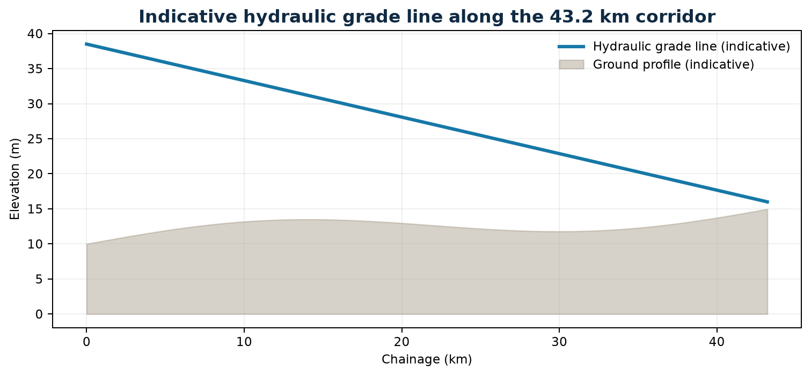
Figure 5-3. Indicative hydraulic grade line along the corridor
Source: Revision 2 controlled project basis; conceptual and not for construction.

5.10 Bustos Dam / AMRIS Terminal Works
Controlled feasibility basis · September 2026
The Bustos / AMRIS terminal must receive the pumped flow, dissipate energy, meter custody transfer, prevent backflow, and introduce water without destabilizing existing headworks or canals. Construction and commissioning must be coordinated around irrigation operations.
At Bustos, the pipeline discharges into an energy-dissipation basin, passes through a measuring flume, and joins the AMRIS canal. The structure must dissipate residual pressure, prevent scour, and measure delivered flow accurately (Item 11, ₱320.00 million).
The flume is the commercial metering point for the offtake agreement and the accounting point for substitution volumes, so its accuracy and calibration are contractually significant.
Design must be coordinated with NIA on canal levels, gate operation, and maintenance access. Calibration standards should be written into the offtake agreement.
DECISION POINT
Metering point: the terminal flume records delivered and billed volumes.

Key requirements and decision checks
- Confirm receiving levels and canal capacity
- Design energy dissipation and erosion protection
- Provide calibrated custody-transfer metering
- Develop tie-in, isolation, and emergency shutdown procedures

6.1 Project Description for Safeguards Review
Controlled feasibility basis · September 2026
Safeguards assessment covers both the fixed five-hectare abstraction complex and the linear 43.2 km corridor, including crossings, valve sites, access routes, and the Bustos terminal. The central issue is the change in source and conveyance mode for irrigation substitution.
For safeguards review the project has three components: the 5.0 ha abstraction complex at San Luis, the 43.2 km pipeline corridor across Pampanga and Bulacan, and the terminal works at Bustos. Each has different impacts and stakeholders.
Because of its scale, flow abstraction, and linear footprint, the project is likely to need a full Environmental Impact Statement under the Philippine EIS System. The final category must be confirmed with the DENR Environmental Management Bureau.
An early scoping meeting with DENR-EMB and the affected LGUs should confirm the category, study scope, and consultation requirements.
KEY FINDING
Components for review: abstraction complex, 43.2 km corridor, and Bustos terminal.

Key requirements and decision checks
- Map direct, indirect, and cumulative areas of influence
- Define construction and operational impact pathways
- Integrate safeguards requirements into design packages
- Maintain a commitments register through delivery

6.2 Physical Environment
Controlled feasibility basis · September 2026
Assessment should characterize river hydrology, water quality, sediment, soils, groundwater, noise, air quality, flood exposure, and climate hazards. Existing measurements are not assumed complete; representative baseline campaigns are required before impact significance is finalized.
Physical-environment topics include river hydrology and the effects of abstraction on downstream flow, flood behaviour around the raised platform, water quality, sediment, air quality and noise during construction, and disposal of spoil and dredged material.
Abstracting 20.00 CMS reduces downstream flow in the lower Pampanga, most noticeably in the dry season. The environmental-flow assessment must show that remaining flows protect aquatic habitat, downstream users, and salinity balance.
Baseline monitoring of water quality, noise, and air quality should begin before construction to provide a reference for compliance monitoring.
DECISION POINT
Key physical impact: reduced downstream dry-season flow, managed through an environmental-flow rule.

Key requirements and decision checks
- Collect wet- and dry-season baseline data
- Screen salinity, erosion, and geohazard exposure
- Assess spoil and hazardous-material pathways
- Define measurable construction and operating limits

6.3 Biological Resources
Controlled feasibility basis · September 2026
The intake, riverbank works, dike, and corridor may affect aquatic organisms, riparian vegetation, agricultural habitats, and localized movement corridors. Desktop screening should be followed by field verification and critical-habitat review where warranted.
The lower Pampanga supports freshwater and brackish fish, crustaceans, and riparian vegetation, and it links to Manila Bay estuarine systems. The intake may trap fish and small organisms, and construction may disturb riverbank habitat.
Mitigation includes low approach velocities and fish-friendly screens at the intake, limiting riverbank clearing, replanting, and timing in-river works to avoid sensitive spawning periods where these are identified.
A biodiversity baseline survey should confirm whether any protected or threatened species are present.
DECISION POINT
Intake measure: low approach velocity and screen design to minimise fish entrainment.

Key requirements and decision checks
- Survey aquatic and riparian receptors
- Confirm protected-area and critical-habitat proximity
- Apply fish-friendly intake criteria
- Plan restoration and invasive-species controls

6.4 Community and Quality-of-Life Conditions
Controlled feasibility basis · September 2026
Potentially affected communities include river-adjacent households, agricultural landholders, road users, and AMRIS-dependent farmers. Assessment should address land access, crop and livelihood effects, construction nuisance, community safety, cultural heritage, and service continuity.
Communities along the corridor are mainly agricultural. Impacts include temporary land occupation, crop loss, access disruption during trenching, construction traffic, noise, and dust. Permanent impacts include easement restrictions over the pipeline and the loss of 5.0 ha of farmland at the site.
Benefits include local employment during construction, more reliable irrigation for AMRIS farmers, and indirect water-security benefits for Metro Manila. Clearly communicating these benefits alongside fair compensation supports social acceptance.
A socio-economic baseline and census of affected households should precede compensation and livelihood-restoration planning.
DECISION POINT
Community focus: fair compensation, maintained access, and livelihood restoration.

Key requirements and decision checks
- Prepare a stakeholder and vulnerability profile
- Screen cultural heritage and Indigenous Peoples requirements
- Map sensitive receptors and access dependencies
- Document irrigation-service expectations and concerns

6.5 Construction Impacts and Mitigation
Controlled feasibility basis · September 2026
Earthworks, dike construction, trenching, crossings, heavy transport, and equipment erection create distinct impact pathways. Contract requirements should apply avoidance, minimization, restoration, and compensation in that order, backed by site-specific management plans.
The main construction impacts are fill haulage traffic, noise and vibration from stone-column installation, trenching dust and access disruption, dewatering discharge, and in-river works at the intake.
Mitigation includes traffic-management plans, restricted working hours near homes, dust suppression, sediment controls on dewatering discharge, phased trenching with prompt reinstatement, and cofferdams for in-river works.
Contracts must include enforceable environmental and social specifications, an independent environmental monitor, and penalties for non-compliance.
DECISION POINT
Contractual control: an ESMP in every works contract, with independent monitoring.

Key requirements and decision checks
- Control dust, noise, vibration, runoff, and turbidity
- Manage traffic, utility strikes, and public access
- Reinstate topsoil and agricultural land
- Require incident reporting, audits, and corrective action

6.6 Operational Impacts and Monitoring
Controlled feasibility basis · September 2026
Operational monitoring should demonstrate compliance with abstraction rules, downstream flow requirements, water-quality limits, noise criteria, and community commitments. Hydrologic, environmental, and operating data should share consistent timestamps and governance.
Operational impacts include continued abstraction affecting downstream flows, sediment disposal from the desanders, noise from the pump stations, energy consumption, and emergency events such as pipe bursts.
Monitoring covers river flow and environmental-flow compliance, water quality at the intake and terminal, sediment disposal, noise at the site boundary, and pipeline integrity. Results are reported to DENR and the stakeholder committee.
An adaptive operating rule should adjust abstraction when monitoring shows environmental thresholds are being approached.
DECISION POINT
Operating control: an adaptive abstraction rule tied to monitored river conditions.

Key requirements and decision checks
- Monitor source and downstream flow
- Track salinity, turbidity, and selected quality indicators
- Review complaints and corrective actions
- Publish agreed compliance summaries
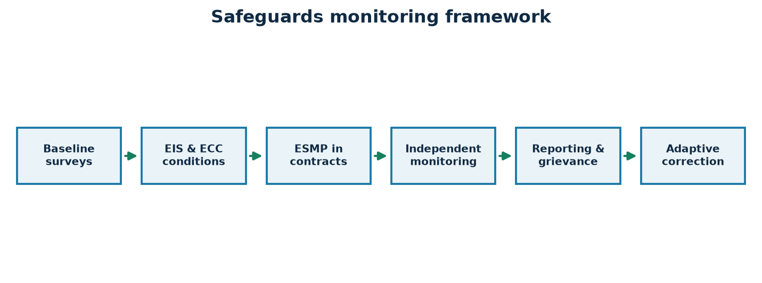
Figure 6-1. Safeguards monitoring framework
Source: Revision 2 controlled project basis; conceptual and not for construction.

6.7 Institutional Requirements and Public Involvement
Controlled feasibility basis · September 2026
Water rights, environmental review, local clearances, agricultural-land matters, and AMRIS operating coordination involve multiple authorities. Engagement should begin before design freeze and continue through disclosure, construction, and operation.
The approvals needed include the NWRB water permit, the DENR ECC, LGU endorsements and permits, road and waterway crossing permits from DPWH and other agencies, and NGCP or distribution-utility interconnection approval.
Public involvement includes scoping consultations, public hearings under the EIS process, an ongoing information programme, and an accessible grievance redress mechanism.
A permit register should track each approval with its prerequisites, lead agency, target date, and status.
DECISION POINT
Approvals: water permit, ECC, LGU endorsements, crossing permits, and grid interconnection.

Key requirements and decision checks
- Prepare a permit and approval register
- Conduct accessible, documented consultations
- Operate a time-bound grievance mechanism
- Formalize inter-agency operating responsibilities

6.8 Safeguards Findings and Commitments
Controlled feasibility basis · September 2026
The project can proceed only after material safeguards uncertainties are converted into verifiable commitments. Water rights, environmental approval, biodiversity and water-quality programs, land and livelihood arrangements, and construction controls should each have an owner and closure evidence.
The safeguards review finds no reason in principle that the project could not be permitted, provided the environmental flow, compensation, and construction controls are applied properly. None of the approvals have been obtained yet.
Commitments are recorded in Annex F with the evidence required for each. They become binding conditions in contracts and in the offtake and financing agreements.
Gate 3 requires the ECC, water permit, and ROW control to be in place before construction mobilisation.
DECISION POINT
Status: permittable in principle, with no approvals yet secured.

Key requirements and decision checks
- Classify commitments by approval gate
- Assign accountable parties and target milestones
- Track evidence and residual risk
- Prevent mobilization where critical commitments remain open

7.1 Cost Estimate Basis and Assumptions
Controlled feasibility basis · September 2026
The ₱14,850.00 million estimate is a feasibility-level control budget built from quantities, benchmark rates, package allowances, contingencies, pre-operating costs, and financing costs. It should be progressively replaced by surveyed quantities, design take-offs, and competitive market evidence.
The cost estimate is a Revision 2 feasibility-level estimate built from 16 controlled items that total ₱14,850.00 million. Quantity-based items include land (50,000 m² at ₱500/m²) and fill (375,000 m³ at ₱450/m³). Other items use parametric or allowance bases.
The estimate includes ₱1,000.00 million (6.73%) of physical and price contingency, ₱380.00 million of interest during construction, and ₱650.00 million for EPCM. It excludes land-value escalation beyond the verified rate, major exchange-rate shifts, and scope changes arising from investigation findings.
A Class 3 estimate at detailed design, supported by market quotations for the pipeline and electromechanical packages, should replace this estimate before financial close.
KEY FINDING
Estimate class: feasibility level, totalling ₱14,850.00 million including 6.73% contingency.

Key requirements and decision checks
- Maintain a dated basis-of-estimate memorandum
- Separate quantity, price, scope, and escalation risks
- Reconcile inclusions and exclusions across packages
- Update foreign-exchange and commodity exposures

7.2 Detailed CAPEX Schedule
Controlled feasibility basis · September 2026
The controlled schedule contains sixteen items summing exactly to ₱14,850.00 million. The 43.2 km pipeline is the dominant line at ₱7,850.00 million, followed by the ₱2,450.00 million electromechanical package, making route certainty and equipment procurement the principal cost-assurance priorities.
The 16-item schedule below is the controlled CAPEX. It is dominated by the pipeline (Item 10, ₱7,850.00 million, 52.86%) and the electromechanical package (Item 9, ₱2,450.00 million, 16.50%). Together these two items make up 69.36% of total cost.
The site-specific resilience items (land, platform fill, ground improvement, polder and revetment, and drainage) total ₱578.75 million, or 3.90% of CAPEX. This is modest compared with the protection they give to the ₱2,450.00 million equipment package.
Cost assurance should concentrate on the two dominant items through early market engagement, pipe-supplier quotations, and independent cost review.
DECISION POINT
Concentration: Items 9 and 10 make up 69.36% of CAPEX.

Key requirements and decision checks
- Trace every line to scope and quantity basis
- Prioritize market testing of dominant items
- Avoid double counting between civil and E&M packages
- Reconcile every change to the approved baseline
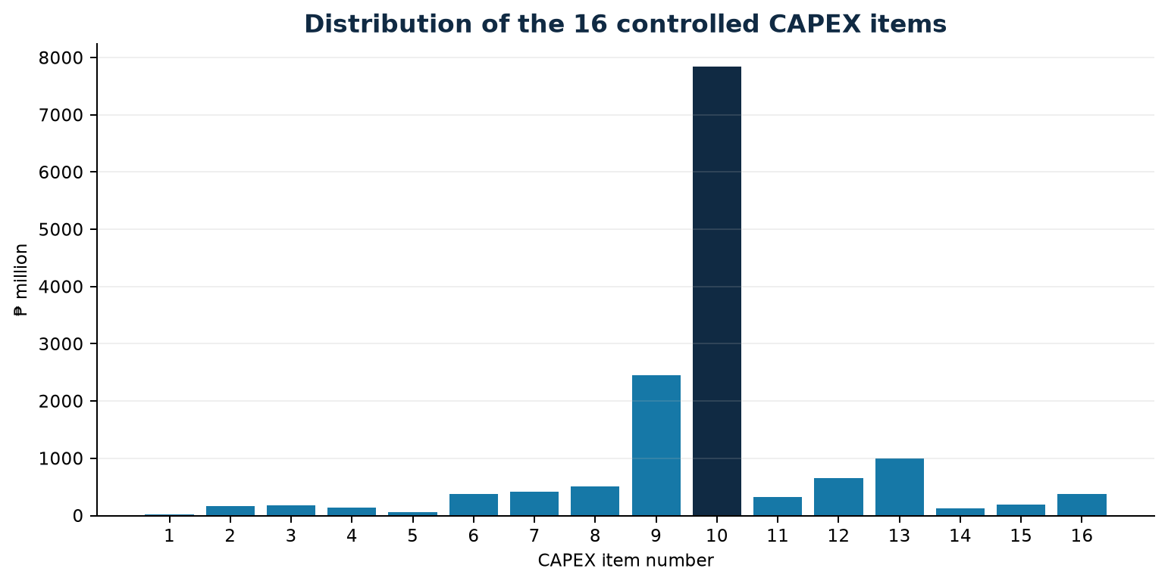
Figure 7-2. Distribution of the 16 controlled CAPEX items
Source: Revision 2 controlled project basis; conceptual and not for construction.
No. | Cost item / component | PHP M | Share
1 | Site Land Acquisition | ₱25.00 | 0.17%
2 | Site Preparation & +6m Platform Raise Earthworks | ₱168.75 | 1.14%
3 | Foundation Ground Improvement | ₱185.00 | 1.25%
4 | Polder Ring Dike & Riverfront Revetment | ₱135.00 | 0.91%
5 | Internal Stormwater Drainage & Retention | ₱65.00 | 0.44%
6 | Low-Lift Intake & Desanding Basin Civil Works | ₱380.00 | 2.56%
7 | Intermediate Balancing Forebay Civil Works | ₱420.00 | 2.83%
8 | High-Lift Pump House & Substation Civil Works | ₱510.00 | 3.43%
9 | Electromechanical & Controls Package | ₱2,450.00 | 16.50%
10 | Bulk Water Transmission Pipeline (43.2 km) | ₱7,850.00 | 52.86%
11 | Bustos Dam / AMRIS Discharge Terminal Structure | ₱320.00 | 2.15%
12 | Engineering, Procurement & Construction Management | ₱650.00 | 4.38%
13 | Physical & Price Contingencies | ₱1,000.00 | 6.73%
14 | Environmental, Social Safeguards & ROW Management | ₱125.00 | 0.84%
15 | Pre-Operating, Testing & Commissioning Expenses | ₱186.25 | 1.25%
16 | Financing Costs During Construction (IDC) | ₱380.00 | 2.56%

7.3 Work-Package Grouping
Controlled feasibility basis · September 2026
Five controlled groups organize related scope and expose interfaces. Package D, transmission pipeline and terminal works, represents ₱8,170.00 million or 55.02%, while Package C, electromechanical and controls, represents ₱2,450.00 million or 16.50%.
The 16 items are grouped into five packages: A (land, earthworks and flood resilience, ₱578.75M), B (hydraulic structures and plant civil works, ₱1,310.00M), C (electromechanical and controls, ₱2,450.00M), D (pipeline and terminal, ₱8,170.00M), and E (soft costs, EPCM, safeguards and financing, ₱2,341.25M).
Package D, at 55.02% of CAPEX, is the largest procurement and should be tendered in several lots by corridor section to broaden contractor competition and reduce delivery risk.
Interfaces between packages, especially between A and B at the platform and between C and D at the high-lift discharge, must be clearly defined in contract documents.
DECISION POINT
Largest package: D, pipeline and terminal, at 55.02%.

Key requirements and decision checks
- Align package boundaries with specialist market capacity
- Allocate ground, interface, and performance risks explicitly
- Coordinate owner-supplied and contractor-supplied equipment
- Protect system-level commissioning responsibility
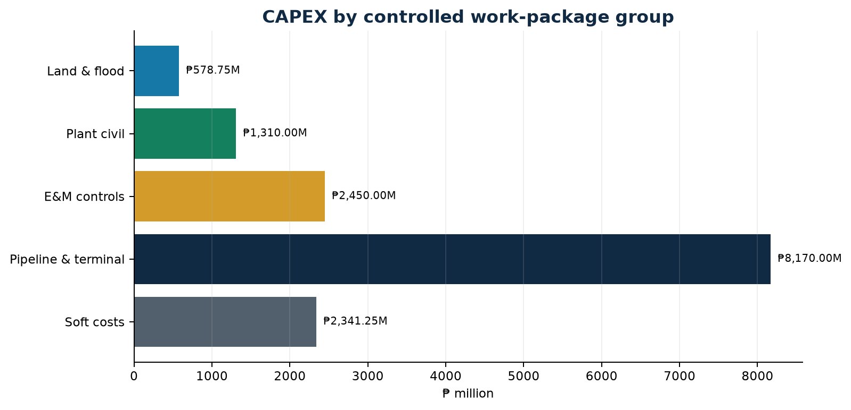
Figure 7-1. CAPEX by controlled work-package group
Source: Revision 2 controlled project basis; conceptual and not for construction.
Work package group | Components | Cost (PHP M) | Share
A. Land, Earthworks & Flood Resilience | Items 1–5 | ₱578.75 | 3.90%
B. Hydraulic Structures & Plant Civil Works | Items 6–8 | ₱1,310.00 | 8.82%
C. Electromechanical & Control Systems | Item 9 | ₱2,450.00 | 16.50%
D. Transmission Pipeline & Terminal Works | Items 10–11 | ₱8,170.00 | 55.02%
E. Soft Costs, EPCM, Safeguards & Financing | Items 12–16 | ₱2,341.25 | 15.77%

7.4 Procurement and Contract Packaging
Controlled feasibility basis · September 2026
Procurement should match contract form to risk: remeasurement where ground quantities remain uncertain, performance-based obligations for plant, and strong interface management across civil, electrical, pipeline, and terminal packages. Prequalification should test directly relevant delivery experience.
The recommended strategy separates early works (Package A enabling and ground improvement), plant civil works (B), electromechanical supply and installation (C), and pipeline lots (D), all managed by an EPCM consultant under Package E.
This multi-package approach gives more control and competition than a single EPC contract, but the owner keeps more interface risk. A single EPC contract would transfer more risk at a higher price. The final choice should reflect lender preference and the sponsor's management capability.
Procurement documents should include performance guarantees, liquidated damages, environmental and social specifications, and clear interface schedules.
DECISION POINT
Strategy: multi-package delivery under EPCM, with the EPC alternative kept open for lender preference.

Key requirements and decision checks
- Market-test packaging before tender
- Require large-pipeline and HDD experience
- Evaluate lifecycle energy performance
- Link award readiness to ROW, permits, and financing

7.5 Thirty-Six-Month Construction Program
Controlled feasibility basis · September 2026
The controlled 36-month program overlaps enabling works, main civil and corridor construction, equipment installation, and commissioning. Critical paths are likely to include ground-improvement dwell time, corridor possession, major crossings, pumps and transformers, energization, and terminal tie-in.
The 36-month programme runs in four overlapping phases: enabling works and ground improvement (months 1–10), civil structures and corridor works (months 7–26), equipment installation and energisation (months 20–33), and commissioning and handover (months 32–36).
The critical path runs through ground-treatment consolidation, then pump-house foundations, equipment installation, and energisation, with the pipeline lots running in parallel. Consolidation delays or late transformer delivery would push out commissioning.
The programme starts only after the pre-construction gates close, and it should include weather allowances and early ordering of long-lead items such as transformers and large pumps.
DECISION POINT
Duration: 36 months from notice to proceed to handover.

Key requirements and decision checks
- Months 1–10: enabling and ground improvement
- Months 7–26: structures and corridor works
- Months 20–33: installation and energization
- Months 32–36: wet commissioning and handover
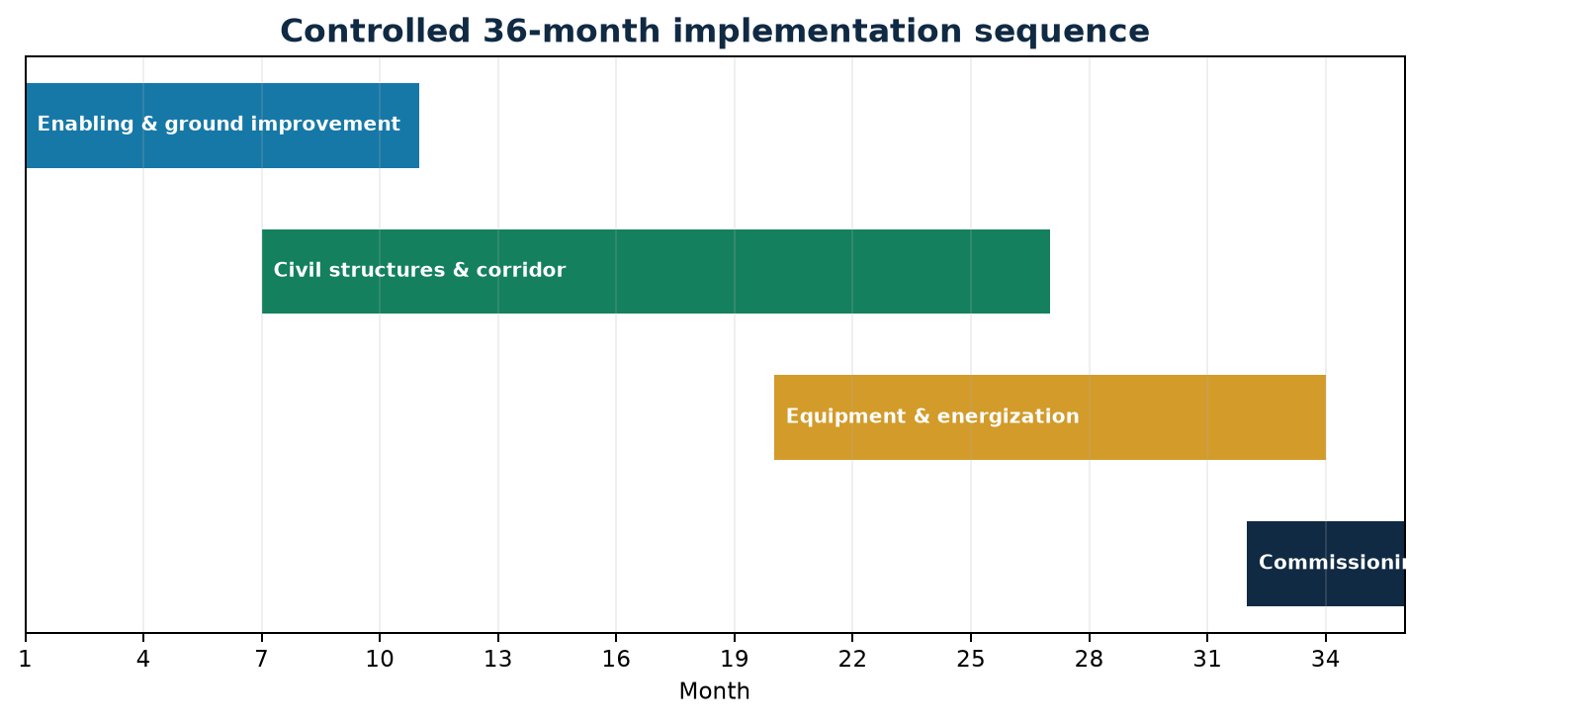
Figure 7-3. Controlled 36-month implementation sequence
Source: Revision 2 controlled project basis; conceptual and not for construction.

7.6 Cost Control and Contingency Governance
Controlled feasibility basis · September 2026
Cost control requires package budgets, commitments, forecasts at completion, change control, contingency authorization, and independent certification. Contingency should be released only against defined risk events or approved scope development.
Cost control needs a baseline budget, change-control procedures, monthly cost reporting, and earned-value tracking. The ₱1,000.00 million contingency should be split between packages according to their risk and released only with documented justification.
Contingency drawdown should be linked to the risk register, so each release corresponds to a risk that has actually occurred and not to scope growth.
Independent cost certification at each funding drawdown gives lenders assurance and supports the disbursement conditions.
DECISION POINT
Governance: contingency released only against documented risk events.

Key requirements and decision checks
- Issue monthly cost and schedule forecasts
- Maintain change and contingency registers
- Require documented approval thresholds
- Reconcile final accounts to the controlled baseline

8.1 Basic Financial Assumptions
Controlled feasibility basis · September 2026
The reconciled base case rests on 20.00 CMS nominal flow, 95% availability, ₱14.50/m³ base tariff, and ₱14,850.00 million CAPEX funded by ₱10,395.00 million of senior debt and ₱4,455.00 million of sponsor equity. The integrated Income Statement, Cash Flow, and Balance Sheet use a common Year 0–30 projection, preserve the supplied Year 1 revenue, OPEX, and EBITDA, and apply disclosed screening assumptions for escalation, VAT, depreciation, tax, and debt amortization.
The financial model uses Year 0 CAPEX of ₱14,850.00 million funded with 70% debt and 30% equity. It applies ₱14.50/m³ on 599.18 million m³ billed volume, 2.50% escalation, 30-year straight-line depreciation, 6.50% interest with three-year grace, and a 25% screening tax rate.
The integrated statements below show revenue, costs, cash, and balance-sheet positions reconciling in every year. They are a screening model, not an audited forecast.
The assumptions should be validated against the actual offtake terms, power tariff, tax treatment, and financing term sheet before lender reliance.
KEY FINDING
Model status: an internally consistent screening model awaiting independent audit.

Key requirements and decision checks
- Confirm nominal versus real conventions
- Independently review escalation, tax, and depreciation treatment
- Validate debt grace and amortization against lender terms
- Document working-capital, reserve, distribution, and terminal-value policies before financing reliance

Projection assumptions and accounting treatment
Assumption | Revision 2 treatment
Capital cost and funding | ₱14,850.00M at Year 0; 70% senior debt (₱10,395.00M) and 30% sponsor equity (₱4,455.00M)
Operating basis | 20.00 CMS nominal flow; 630.72 million m³ nominal annual volume; 95% availability; 599.18 million m³ billed
Revenue | Year 1 net operating revenue fixed at ₱8,688.17M; 2.50% annual escalation thereafter; billings shown gross of 12% VAT
Operating costs | Year 1 power ₱1,885.00M, chemicals ₱71.90M, and fixed OPEX ₱266.75M; total Year 1 OPEX ₱2,223.65M; 2.50% escalation
Depreciation | Straight-line over 30 years on the full controlled CAPEX; ₱495.00M annually; no residual value assumed
Debt service | 6.50% annual interest; three-year principal grace; straight-line principal over Years 4–15; annual principal ₱866.25M
Income tax | 25% screening rate applied to positive income before tax; tax losses and deferred tax are not recognized
Working capital / distributions | No working-capital balance, dividends, reserve accounts, or terminal value included in these illustrative statements
The schedules below are an internally consistent screening model in PHP millions. They preserve the supplied Revision 2 Year 1 revenue, OPEX, and EBITDA anchors while replacing the older ₱11,600.00 million statement basis shown in the reference tables. Values after Year 1 are calculated projections, not audited forecasts.

Income Statement
Income Statement · PHP million | Year 0 | Year 1 | Year 5 | Year 10
OPERATING REVENUE
Nominal bulk production (million m³) | — | 630.72 | 630.72 | 630.72
Billed production at 95% availability | — | 599.18 | 599.18 | 599.18
Gross customer billings incl. VAT | — | 9,730.75 | 10,740.93 | 12,152.37
Less: output VAT (12%) | — | 1,042.58 | 1,150.81 | 1,302.04
Net operating revenue | — | 8,688.17 | 9,590.11 | 10,850.33
OPERATING EXPENSES
Power | — | 1,885.00 | 2,080.69 | 2,354.11
Chemicals | — | 71.90 | 79.36 | 89.79
Management, maintenance, labor and insurance | — | 266.75 | 294.44 | 333.13
Total OPEX | — | 2,223.65 | 2,454.49 | 2,777.03
EBITDA | — | 6,464.52 | 7,135.62 | 8,073.30
Depreciation | — | 495.00 | 495.00 | 495.00
Income before interest and tax | — | 5,969.52 | 6,640.62 | 7,578.30
Interest expense | — | 675.68 | 619.37 | 337.84
Provision for income tax | — | 1,323.46 | 1,505.31 | 1,810.12
Net income | — | 3,970.38 | 4,515.94 | 5,430.35
Source: Revision 2 financial projection; calculated values in PHP millions and subject to independent model audit.

Income Statement — continued | Year 15 | Year 20 | Year 25 | Year 30
OPERATING REVENUE
Nominal bulk production (million m³) | 630.72 | 630.72 | 630.72 | 630.72
Billed production at 95% availability | 599.18 | 599.18 | 599.18 | 599.18
Gross customer billings incl. VAT | 13,749.30 | 15,556.07 | 17,600.26 | 19,913.08
Less: output VAT (12%) | 1,473.14 | 1,666.72 | 1,885.74 | 2,133.54
Net operating revenue | 12,276.16 | 13,889.34 | 15,714.52 | 17,779.54
OPERATING EXPENSES
Power | 2,663.46 | 3,013.46 | 3,409.45 | 3,857.48
Chemicals | 101.59 | 114.94 | 130.05 | 147.14
Management, maintenance, labor and insurance | 376.91 | 426.44 | 482.48 | 545.88
Total OPEX | 3,141.96 | 3,554.84 | 4,021.97 | 4,550.49
EBITDA | 9,134.20 | 10,334.51 | 11,692.55 | 13,229.04
Depreciation | 495.00 | 495.00 | 495.00 | 495.00
Income before interest and tax | 8,639.20 | 9,839.51 | 11,197.55 | 12,734.04
Interest expense | 56.31 | — | — | —
Provision for income tax | 2,145.72 | 2,459.88 | 2,799.39 | 3,183.51
Net income | 6,437.17 | 7,379.63 | 8,398.16 | 9,550.53
Source: Revision 2 financial projection; calculated values in PHP millions and subject to independent model audit.

Cash Flow
Cash Flow · PHP million | Year 0 | Year 1 | Year 5 | Year 10
CASH INFLOWS
Senior debt proceeds | 10,395.00 | — | — | —
Sponsor equity proceeds | 4,455.00 | — | — | —
Net operating revenue | — | 8,688.17 | 9,590.11 | 10,850.33
Total cash inflows | 14,850.00 | 8,688.17 | 9,590.11 | 10,850.33
CASH OUTFLOWS
Project CAPEX | 14,850.00 | — | — | —
Operating expenses | — | 2,223.65 | 2,454.49 | 2,777.03
Interest paid | — | 675.68 | 619.37 | 337.84
Principal repayment | — | — | 866.25 | 866.25
Income tax paid | — | 1,323.46 | 1,505.31 | 1,810.12
Total cash outflows | 14,850.00 | 4,222.79 | 5,445.43 | 5,791.24
Net cash flow | — | 4,465.38 | 4,144.69 | 5,059.10
Cash, beginning | — | — | 17,734.74 | 40,252.28
Cash, ending | — | 4,465.38 | 21,879.43 | 45,311.38
Source: Revision 2 financial projection; calculated values in PHP millions and subject to independent model audit.

Cash Flow — continued | Year 15 | Year 20 | Year 25 | Year 30
CASH INFLOWS
Senior debt proceeds | — | — | — | —
Sponsor equity proceeds | — | — | — | —
Net operating revenue | 12,276.16 | 13,889.34 | 15,714.52 | 17,779.54
Total cash inflows | 12,276.16 | 13,889.34 | 15,714.52 | 17,779.54
CASH OUTFLOWS
Project CAPEX | — | — | — | —
Operating expenses | 3,141.96 | 3,554.84 | 4,021.97 | 4,550.49
Interest paid | 56.31 | — | — | —
Principal repayment | 866.25 | — | — | —
Income tax paid | 2,145.72 | 2,459.88 | 2,799.39 | 3,183.51
Total cash outflows | 6,210.24 | 6,014.72 | 6,821.36 | 7,734.00
Net cash flow | 6,065.92 | 7,874.63 | 8,893.16 | 10,045.53
Cash, beginning | 67,522.12 | 103,241.65 | 144,601.57 | 191,315.21
Cash, ending | 73,588.04 | 111,116.28 | 153,494.73 | 201,360.74
Source: Revision 2 financial projection; calculated values in PHP millions and subject to independent model audit.

Balance Sheet
Balance Sheet · PHP million | Year 0 | Year 1 | Year 5 | Year 10
ASSETS
Cash and cash equivalents | — | 4,465.38 | 21,879.43 | 45,311.38
Gross property, plant and equipment | 14,850.00 | 14,850.00 | 14,850.00 | 14,850.00
Less: accumulated depreciation | — | 495.00 | 2,475.00 | 4,950.00
Net property, plant and equipment | 14,850.00 | 14,355.00 | 12,375.00 | 9,900.00
Total assets | 14,850.00 | 18,820.38 | 34,254.43 | 55,211.38
LIABILITIES
Senior debt | 10,395.00 | 10,395.00 | 8,662.50 | 4,331.25
Total liabilities | 10,395.00 | 10,395.00 | 8,662.50 | 4,331.25
EQUITY
Sponsor contributed equity | 4,455.00 | 4,455.00 | 4,455.00 | 4,455.00
Retained earnings | — | 3,970.38 | 21,136.93 | 46,425.13
Total equity | 4,455.00 | 8,425.38 | 25,591.93 | 50,880.13
Total liabilities and equity | 14,850.00 | 18,820.38 | 34,254.43 | 55,211.38
Source: Revision 2 financial projection; calculated values in PHP millions and subject to independent model audit.

Balance Sheet — continued | Year 15 | Year 20 | Year 25 | Year 30
ASSETS
Cash and cash equivalents | 73,588.04 | 111,116.28 | 153,494.73 | 201,360.74
Gross property, plant and equipment | 14,850.00 | 14,850.00 | 14,850.00 | 14,850.00
Less: accumulated depreciation | 7,425.00 | 9,900.00 | 12,375.00 | 14,850.00
Net property, plant and equipment | 7,425.00 | 4,950.00 | 2,475.00 | —
Total assets | 81,013.04 | 116,066.28 | 155,969.73 | 201,360.74
LIABILITIES
Senior debt | — | — | — | —
Total liabilities | — | — | — | —
EQUITY
Sponsor contributed equity | 4,455.00 | 4,455.00 | 4,455.00 | 4,455.00
Retained earnings | 76,558.04 | 111,611.28 | 151,514.73 | 196,905.74
Total equity | 81,013.04 | 116,066.28 | 155,969.73 | 201,360.74
Total liabilities and equity | 81,013.04 | 116,066.28 | 155,969.73 | 201,360.74
Source: Revision 2 financial projection; calculated values in PHP millions and subject to independent model audit.

Statement reconciliation
Control check | Result
Year 0 sources and uses | ₱10,395.00M debt + ₱4,455.00M equity = ₱14,850.00M CAPEX
Year 1 operating identity | ₱8,688.17M revenue − ₱2,223.65M OPEX = ₱6,464.52M EBITDA
Cash roll-forward | Beginning cash + net cash flow = ending cash in every projected year
Balance-sheet identity | Total assets = total liabilities + total equity in every projected year
Debt roll-forward | Opening debt − principal repayment = closing debt; debt is fully repaid in Year 15

8.2 Revenue, OPEX and EBITDA
Controlled feasibility basis · September 2026
Controlled Year 1 revenue of ₱8,688.17 million less OPEX of ₱2,223.65 million produces EBITDA of ₱6,464.52 million, a derived margin of about 74.4%. Power is the dominant controllable operating exposure.
Year 1 revenue is ₱8,688.17 million. OPEX is ₱2,223.65 million, made up of power ₱1,885.00M, chemicals ₱71.90M, and fixed costs ₱266.75M. EBITDA is ₱6,464.52 million, a 74.4% margin.
Power accounts for about 85% of OPEX, so the energy tariff is the largest operating-cost risk. The sensitivity analysis in Section 8.7 shows how a higher power tariff reduces EBITDA.
A long-term power supply agreement or tariff indexation in the offtake agreement would reduce this exposure.
DECISION POINT
Operating margin: 74.4% in Year 1, with power making up about 85% of OPEX.

Key requirements and decision checks
- Reconcile tariff-volume rounding
- Validate power consumption against pump curves
- Develop maintenance and replacement allowances
- Secure an enforceable tariff-adjustment mechanism
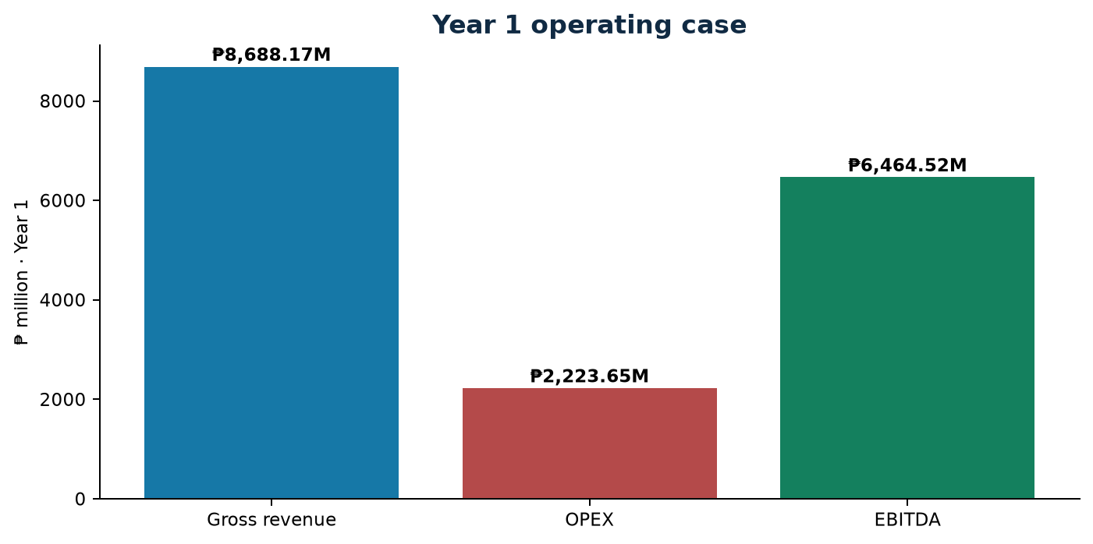
Figure 8-1. Year 1 operating case
Source: Revision 2 controlled project basis; conceptual and not for construction.

8.3 Capital Structure and Debt Terms
Controlled feasibility basis · September 2026
The financing plan uses ₱10,395.00 million senior debt and ₱4,455.00 million sponsor equity, exactly matching total CAPEX. Debt is stated at 6.50% annually over 15 years with a three-year grace period.
Senior debt is ₱10,395.00 million at 6.50% over 15 years with a three-year grace period. Sponsor equity is ₱4,455.00 million. Annual principal repayment after the grace period is ₱866.25 million.
The 70/30 structure is typical for contracted infrastructure. Lenders will expect security over project assets and contracts, reserve accounts, and step-in rights.
Term sheets from prospective lenders should confirm the rate, tenor, grace period, and covenants assumed here.
DECISION POINT
Structure: 70% debt at 6.50% over 15 years, with a 3-year grace period.

Key requirements and decision checks
- Define drawdown and capitalization mechanics
- Negotiate covenant and security packages
- Address cost-overrun and reserve funding
- Assess interest-rate and currency exposure

8.4 Debt-Service Capacity
Controlled feasibility basis · September 2026
The controlled profile reports minimum DSCR of 1.65x and average DSCR of 2.15x. This indicates preliminary headroom, but lender reliance requires reconciliation of grace, amortization, EBITDA escalation, reserves, and downside cases.
Debt service coverage has a minimum of 1.65x and an average of 2.15x over the 15-year debt term. The minimum occurs when principal repayments begin and EBITDA has escalated least.
A 1.65x minimum gives good headroom above a typical lender covenant of about 1.20–1.30x, which provides some resilience to tariff, power, or availability stress.
The debt-service reserve and lock-up covenants should be tested under downside scenarios.
DECISION POINT
Coverage: minimum 1.65x and average 2.15x.

Key requirements and decision checks
- Test tariff, power, and availability stresses
- Confirm the timing of first principal payment
- Define debt-service reserve requirements
- Run lender cases against verified hydrology
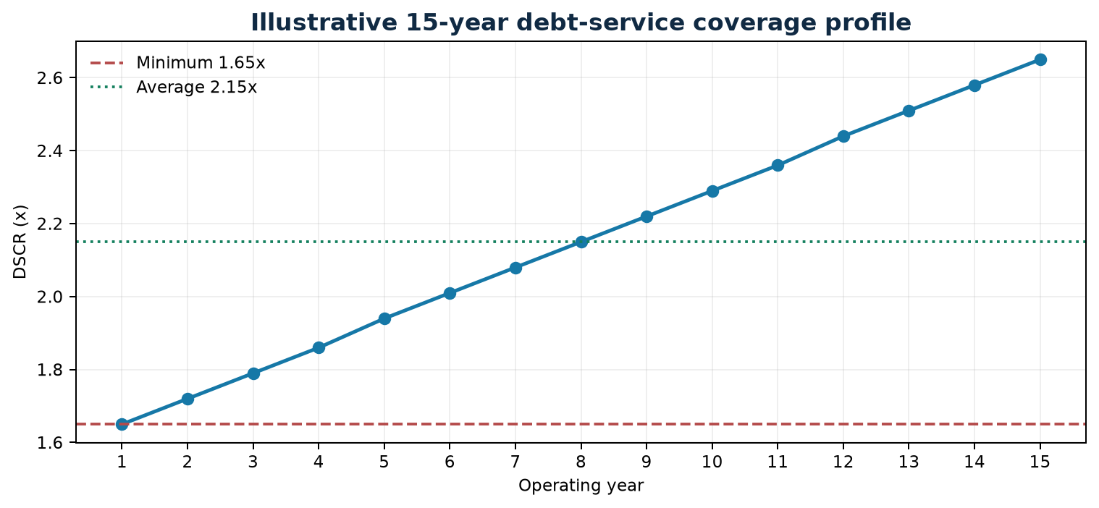
Figure 8-2. Illustrative 15-year DSCR profile
Source: Revision 2 controlled project basis; conceptual and not for construction.
Year | Debt service (₱B) | DSCR
1 | 1.54 | 1.65x
2 | 1.50 | 1.72x
3 | 1.45 | 1.79x
4 | 1.41 | 1.86x
5 | 1.36 | 1.94x
6 | 1.32 | 2.01x
7 | 1.27 | 2.08x
8 | 1.23 | 2.15x
9 | 1.19 | 2.22x
10 | 1.14 | 2.29x
11 | 1.10 | 2.36x
12 | 1.05 | 2.44x
13 | 1.01 | 2.51x
14 | 0.96 | 2.58x
15 | 0.92 | 2.65x

8.5 Project and Equity Returns
Controlled feasibility basis · September 2026
Project FIRR is 18.20%, equity FIRR is 21.50%, and FNPV at 8.5% WACC is ₱16,850 million. The higher equity return is directionally consistent with leverage where debt cost is below project return.
The project FIRR is 18.20%, the equity FIRR is 21.50%, and the FNPV at 8.5% WACC is ₱16,850 million. These are the controlled Revision 2 return metrics.
Returns exceed typical hurdle rates for regulated water infrastructure, which suggests the project could attract private participation or support a lower tariff.
The methods used to calculate the returns, including their timing, tax, and terminal-value treatment, should be documented and independently audited.
DECISION POINT
Returns: FIRR 18.20%, equity FIRR 21.50%, FNPV ₱16,850M.

Key requirements and decision checks
- Document cash-flow horizon and terminal value
- Confirm pre-tax or post-tax treatment
- Disclose the WACC derivation
- Subject formulas to independent audit
Financing / return metric | Value
Senior Debt (70%) | ₱10,395.00 M
Sponsor Equity (30%) | ₱4,455.00 M
Debt Term / Rate | 15 years @ 6.50% p.a. (3-year grace)
Gross Annual Revenue (Year 1) | ₱8,688.17 M
Annual OPEX (Year 1) | ₱2,223.65 M
EBITDA (Year 1) | ₱6,464.52 M
Project FIRR | 18.20%
Equity FIRR | 21.50%
Financial NPV @ 8.5% WACC | ₱16,850 M
Minimum / Average DSCR | 1.65x / 2.15x
EIRR / ENPV @ 10% SDR | 23.50% / ₱29,500 M

8.6 Economic Evaluation
Controlled feasibility basis · September 2026
EIRR of 23.50% and ENPV of ₱29,500 million at a 10% social discount rate indicate a positive economic case. Supporting analysis should explain shadow pricing, transfer exclusions, and the quantified value of irrigation and broader water-security benefits.
Economic evaluation at a 10% social discount rate gives an EIRR of 23.50% and an ENPV of ₱29,500 million. The economic benefits include avoided Angat releases valued for municipal supply, secured irrigation production, and drought-resilience benefits.
The EIRR is well above the 10% social discount rate, which supports NEDA endorsement. The benefits rely on the substitution being recognised in water allocation.
The economic analysis should be updated using NEDA shadow prices and a documented valuation of the water benefits.
DECISION POINT
Economic case: EIRR 23.50% against a 10% social discount rate.

Key requirements and decision checks
- Document benefit streams and counterfactual
- Apply approved economic conversion factors
- Include environmental and social costs
- Test distributional effects and non-monetized impacts

8.7 Sensitivity and Scenario Analysis
Controlled feasibility basis · September 2026
The screening model varies tariff, power price, and availability because they directly influence revenue and operating margin. Results are management sensitivities rather than audited forecasts and should be read alongside source-yield and offtaker risks.
Screening sensitivities show EBITDA falling to about ₱4,967 million at a ₱12/m³ tariff, ₱5,885 million at a ₱8.50/kWh power tariff, and ₱5,785 million at 85% availability, compared with the ₱6,464.52 million base.
Tariff has the largest effect, followed by availability and power cost. Combined downside cases should be tested in the lender model.
The interactive dashboard allows these sensitivities to be explored in real time.
DECISION POINT
Most sensitive variable: the offtake tariff.

Key requirements and decision checks
- Test tariff from ₱12–18/m³
- Test power from ₱5.50–8.50/kWh
- Test availability from 85–98%
- Report FIRR, FNPV, EBITDA, and simple payback consistently
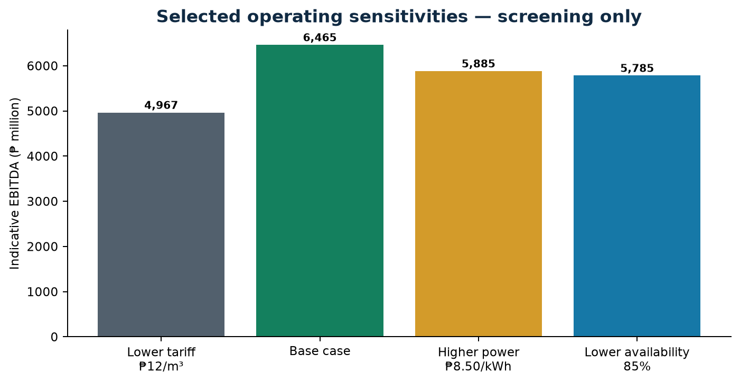
Figure 8-3. Selected operating sensitivities
Source: Revision 2 controlled project basis; conceptual and not for construction.

8.8 Financial Conclusions and Audit Requirements
Controlled feasibility basis · September 2026
The controlled indicators support continued development, not unconditional financing reliance. A bankable model must reconcile technical availability, construction drawdown, operating costs, taxation, escalation, reserves, debt terms, and contracted revenues.
The financial indicators support moving to the next development stage. Financing reliance requires an audited model, executed offtake, a power agreement, and committed debt terms.
The main financial risks are tariff level and payment security, energy cost, availability, and construction cost overrun.
An independent model audit and lender technical advisor review are prerequisites to financial close.
DECISION POINT
Status: supports development, with financing reliance still pending audit and agreements.

Key requirements and decision checks
- Commission independent model audit
- Reconcile all controlled and derived figures
- Link lender cases to verified technical inputs
- Obtain credit-approved commercial terms

9.1 Consolidated Findings
Controlled feasibility basis · September 2026
The concept is strategically relevant and technically plausible, with positive controlled financial and economic indicators. Its viability remains conditional on source reliability, soft-ground performance, corridor control, approvals, energy exposure, and a bankable offtake structure.
The project addresses a real water-security need and has a technically coherent five-hectare concept, a controlled ₱14,850.00 million CAPEX, and positive financial and economic returns.
Its viability depends on confirming dry-season source yield, soft-ground performance, corridor control, approvals, and a bankable offtake arrangement.
One controlled parameter register should govern every future revision.
KEY FINDING
Finding: strategically justified and technically plausible, with viability still conditional.

Key requirements and decision checks
- Protect the substitution logic in all agreements
- Prioritize pipeline and E&M cost assurance
- Close hydrologic and geotechnical evidence gaps
- Maintain one controlled parameter register

9.2 Critical Risks and Mitigation
Controlled feasibility basis · September 2026
The highest-consequence risks span source yield, water rights, settlement, flood and scour, corridor acquisition, crossings, power cost, construction interfaces, offtaker credit, and financial-model assumptions. Mitigation must be owned, funded, scheduled, and linked to decision gates.
The critical risks are source yield, water rights, soft ground, flood and scour, corridor acquisition, power cost, construction interfaces, offtaker credit, and model assumptions. The risk heat map ranks them by likelihood and impact.
Risks rated high on both likelihood and impact, particularly source yield, corridor ROW, and offtaker credit, need early action and are tied to specific gates.
Risk owners and mitigation budgets should be assigned and reviewed at each gate.
DECISION POINT
Top risks: source yield, corridor ROW, and offtaker credit.

Key requirements and decision checks
- Treat uncertainty before transferring residual risk
- Use independent reviews for material assumptions
- Connect contingency use to realized risks
- Escalate gate-blocking risks to sponsors
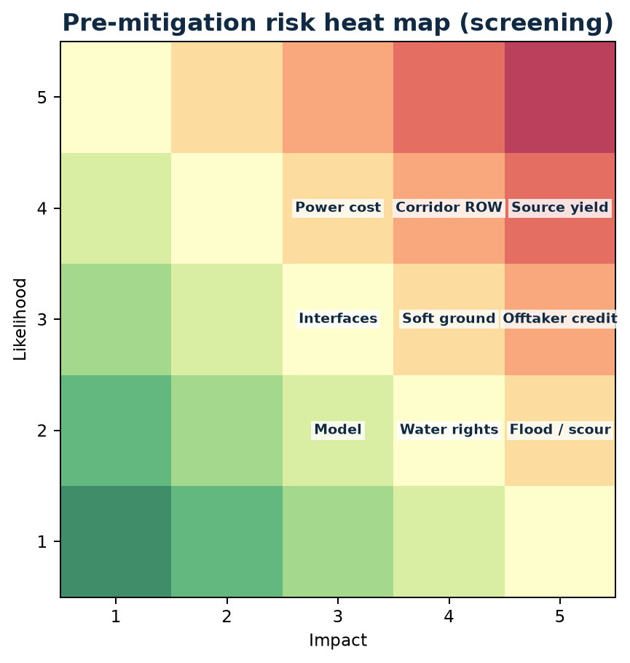
Figure 9-1. Pre-mitigation risk heat map
Source: Revision 2 controlled project basis; conceptual and not for construction.

9.3 Decision Gates
Controlled feasibility basis · September 2026
Investment progression should follow sequential evidence-based gates: source and yield, ground and hydraulics, safeguards and corridor, commercial close, independent assurance, financial close, and notice to proceed. A failed gate pauses commitment rather than shifting unresolved risk into construction.
Six gates govern progress: source and yield, ground and hydraulics, E&S and ROW, the commercial agreement, independent assurance, and financial close with notice to proceed.
Each gate has defined evidence and an approving authority. Failing a gate pauses commitment until it is resolved.
The gates stop unresolved risk from being carried into construction.
DECISION POINT
Rule: no mobilisation before Gates 1–6 are closed.

Key requirements and decision checks
- Define entry and exit evidence for each gate
- Assign approving authorities
- Record conditions and residual risks
- Do not mobilize before critical approvals and land access
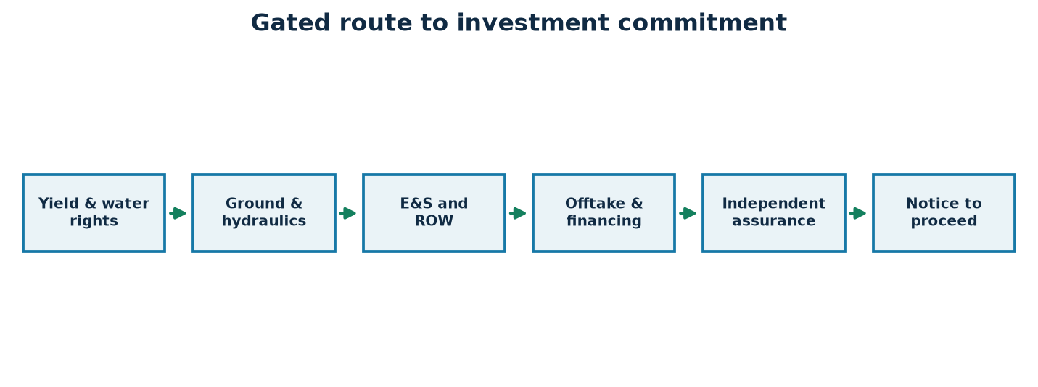
Figure 9-2. Gated route to investment commitment
Source: Revision 2 controlled project basis; conceptual and not for construction.

9.4 Recommendation and Next Actions
Controlled feasibility basis · September 2026
Proceed to the next development stage subject to completion of the stated investigations, approvals, land controls, commercial agreements, and independent reviews. No construction commitment is recommended until critical gates demonstrate that the 20.00 CMS service can be delivered safely, lawfully, and financeably.
The study recommends proceeding to the next development stage and funding the hydrologic and geotechnical investigations, corridor survey, safeguards studies, and commercial negotiations.
No construction commitment is recommended until the gates show safe, lawful, and financeable delivery of 20.00 CMS.
Immediate actions are to mobilise the investigations, form the inter-agency working group, and start offtake and power negotiations.
DECISION POINT
Recommendation: proceed to development; construction to follow only after the gates close.

Key requirements and decision checks
- Launch hydrologic and geotechnical investigations
- Advance corridor survey and stakeholder engagement
- Develop offtake and power term sheets
- Commission independent technical and financial due diligence

Annex A — Parameter Register and Revision Matrix
Controlled feasibility basis · September 2026
The parameter register is the report’s authoritative numeric cross-check. It identifies controlled Revision 2 values, their report location, and whether each is a supplied value, a derived arithmetic result, or a requirement for verification.
The master parameter register below consolidates every controlling engineering and financial value. Changes require a revision entry and an approval.

Use and control requirements
- Resolve inconsistencies through formal revision control
- Carry exact units and rounding conventions
- Record the source and approval owner for every change

Master parameter register
Parameter | Revision 2 value | Basis
Design flow | 20.00 CMS · 1.728M m³/day · 630.72M m³/yr | Controlled
Availability / billed volume | 95% · 599.18M m³/yr | Derived
Site area | 5.0 ha (50,000 m²) · 250 m × 200 m | Controlled
Land cost | ₱500/m² · ₱25.00M | Controlled
Natural grade / 100-yr flood | El. +4.00 m / El. +9.00 m MSL | Assumption to verify
Platform / freeboard | El. +10.00 m MSL (+6.0 m raise) · 1.00 m | Controlled
Polder dike | 0.90 km · crest El. +10.50 m MSL | Controlled
Fill volume | 375,000 m³ @ ₱450/m³ · ₱168.75M | Controlled
Soft clay thickness | 8.5–12 m | Assumption to verify
PVD + surcharge | ≈35,000 m² | Controlled
Stone columns | 800 mm to ~16 m · ≈15,000 m² | Controlled
Stage 1 pumps | 9 × 2.5 CMS · 7.5 m TDH · 250 kW (8+1) | Controlled
Stage 2 pumps | 9 × 2.5 CMS · 28.5 m TDH · 1,050 kW 6.6 kV (8+1) | Controlled
Forebay | 60,000 m³ | Controlled
Power supply | 69 kV · 2 × 25 MVA | Controlled
Pipeline | 43.2 km twin steel barrels | Controlled
CAPEX | ₱14,850.00M (16 items, 5 packages) | Controlled
Package A / B / C | ₱578.75M / ₱1,310.00M / ₱2,450.00M | Controlled
Package D / E | ₱8,170.00M / ₱2,341.25M | Controlled
Debt / equity | ₱10,395.00M (70%) / ₱4,455.00M (30%) | Controlled
Debt terms | 15 yrs @ 6.50% · 3-yr grace | Controlled
Tariff | ₱14.50/m³ | Assumption
Revenue / OPEX / EBITDA (Y1) | ₱8,688.17M / ₱2,223.65M / ₱6,464.52M | Controlled
FIRR / equity FIRR | 18.20% / 21.50% | Controlled
FNPV @ 8.5% | ₱16,850M | Controlled
DSCR min / avg | 1.65x / 2.15x | Controlled
EIRR / ENPV @ 10% | 23.50% / ₱29,500M | Controlled

Annex B — Complete CAPEX Schedule
Controlled feasibility basis · September 2026
The complete CAPEX schedule provides estimator-level traceability from each of the sixteen controlled line items to its quantity or scope basis. The listed items reconcile exactly to ₱14,850.00 million.
Items 9 and 10 together account for 69.36% of the total and should receive the earliest independent cost review.

Use and control requirements
- Validate quantities against detailed design
- Obtain market evidence for high-value packages
- Document exclusions, escalation, and foreign-exchange exposure
No. | Cost item / component | PHP M | Basis
1 | Site Land Acquisition | ₱25.00 | 50,000 m² (5.0 ha) @ ₱500/m² verified local market rate
2 | Site Preparation & +6m Platform Raise Earthworks | ₱168.75 | 375,000 m³ select granular fill delivered and compacted @ ₱450/m³
3 | Foundation Ground Improvement | ₱185.00 | PVD + surcharge across 35,000 m²; vibro stone columns across 15,000 m²
4 | Polder Ring Dike & Riverfront Revetment | ₱135.00 | 0.90 km perimeter dike, 6 m crest road, Class B riprap armor
5 | Internal Stormwater Drainage & Retention | ₱65.00 | 15,000 m³ retention pond, concrete collectors, 2 × 1.5 CMS pumps
6 | Low-Lift Intake & Desanding Basin Civil Works | ₱380.00 | River intake structure, dual traveling screens, 2-cell vortex desanders
7 | Intermediate Balancing Forebay Civil Works | ₱420.00 | 60,000 m³ reinforced concrete / geomembrane-lined balancing basin
8 | High-Lift Pump House & Substation Civil Works | ₱510.00 | Heavy pump hall, gantry cranes, foundation pads, 69 kV switchyard
9 | Electromechanical & Controls Package | ₱2,450.00 | 18 pump sets, VFDs, dual 25 MVA transformers, SCADA
10 | Bulk Water Transmission Pipeline (43.2 km) | ₱7,850.00 | 43.2 km corridor, steel pipe barrels, valves, trenching, HDD crossings
11 | Bustos Dam / AMRIS Discharge Terminal Structure | ₱320.00 | Energy dissipation basin, flow metering flume, AMRIS canal tie-in
12 | Engineering, Procurement & Construction Management | ₱650.00 | Detailed design, surveys, geotechnical borings, construction CM
13 | Physical & Price Contingencies | ₱1,000.00 | Approximately 7.3% standard infrastructure contingency allowance
14 | Environmental, Social Safeguards & ROW Management | ₱125.00 | Pipeline easement acquisition, crop compensation, DENR ECC compliance
15 | Pre-Operating, Testing & Commissioning Expenses | ₱186.25 | Hydrotesting, hydraulic balancing, trial operation, operator training
16 | Financing Costs During Construction (IDC) | ₱380.00 | Capitalized interest during 36-month construction drawdown

Annex C — Package Grouping Summary
Controlled feasibility basis · September 2026
The package summary reconciles the sixteen cost items into five procurement groups. Package D and Package C together dominate capital exposure and therefore require the earliest market testing, route certainty, and interface definition.
The package totals sum to ₱14,850.00 million and their shares sum to 100.00%.

Use and control requirements
- Confirm package boundaries and owner-retained scope
- Align tender sequence with permits and land access
- Maintain a package-level risk and contingency register
Work package group | Components | Cost (PHP M) | Share
A. Land, Earthworks & Flood Resilience | Items 1–5 | ₱578.75 | 3.90%
B. Hydraulic Structures & Plant Civil Works | Items 6–8 | ₱1,310.00 | 8.82%
C. Electromechanical & Control Systems | Item 9 | ₱2,450.00 | 16.50%
D. Transmission Pipeline & Terminal Works | Items 10–11 | ₱8,170.00 | 55.02%
E. Soft Costs, EPCM, Safeguards & Financing | Items 12–16 | ₱2,341.25 | 15.77%

Annex D — Financial Corollaries and Return Metrics
Controlled feasibility basis · September 2026
The financial corollaries reproduce the controlling funding, operating, return, and coverage values. They are decision metrics, not a substitute for a complete audited model with tax, escalation, reserve, and contractual assumptions.
Debt of ₱10,395.00M plus equity of ₱4,455.00M reconciles exactly to the controlled CAPEX.

Use and control requirements
- Reconcile debt and equity to CAPEX
- Trace revenue, OPEX, and EBITDA
- Document all return conventions before lender use
Financing / return metric | Value
Senior Debt (70%) | ₱10,395.00 M
Sponsor Equity (30%) | ₱4,455.00 M
Debt Term / Rate | 15 years @ 6.50% p.a. (3-year grace)
Gross Annual Revenue (Year 1) | ₱8,688.17 M
Annual OPEX (Year 1) | ₱2,223.65 M
EBITDA (Year 1) | ₱6,464.52 M
Project FIRR | 18.20%
Equity FIRR | 21.50%
Financial NPV @ 8.5% WACC | ₱16,850 M
Minimum / Average DSCR | 1.65x / 2.15x
EIRR / ENPV @ 10% SDR | 23.50% / ₱29,500 M
Statement control | Treatment
Projection horizon | Years 0–30 with milestone columns at Years 0, 1, 5, 10, 15, 20, 25 and 30
Cross-statement links | Net income accumulates in retained earnings; cash flow updates cash; closing debt updates liabilities
Reconciliation status | Assets equal liabilities plus equity in every projected year
Reliance | Screening projection subject to independent tax, accounting, commercial and lender review

Annex E — Fifteen-Year Debt-Service Profile
Controlled feasibility basis · September 2026
The fifteen-year profile illustrates the relationship between scheduled debt service and operating cash generation. The reported 1.65x minimum and 2.15x average remain subject to confirmation of grace-period mechanics and the full financing term sheet.
Coverage is lowest when principal repayment begins after the three-year grace period.

Use and control requirements
- Reconcile opening debt and interest
- Validate EBITDA escalation
- Test downside coverage and reserve adequacy
Figure 8-2. Illustrative 15-year DSCR profile
Source: Revision 2 controlled project basis; conceptual and not for construction.
Year | Debt service (₱B) | EBITDA (₱B) | DSCR
1 | 1.54 | 6.46 | 1.65x
2 | 1.50 | 6.63 | 1.78x
3 | 1.45 | 6.79 | 1.88x
4 | 1.41 | 6.96 | 1.96x
5 | 1.36 | 7.14 | 2.02x
6 | 1.32 | 7.31 | 2.08x
7 | 1.27 | 7.50 | 2.12x
8 | 1.23 | 7.68 | 2.16x
9 | 1.19 | 7.88 | 2.19x
10 | 1.14 | 8.07 | 2.22x
11 | 1.10 | 8.28 | 2.25x
12 | 1.05 | 8.48 | 2.28x
13 | 1.01 | 8.69 | 2.31x
14 | 0.96 | 8.91 | 2.34x
15 | 0.92 | 9.13 | 2.41x

Annex F — Environmental and Social Commitment Register
Controlled feasibility basis · September 2026
The commitment register converts safeguards findings into accountable actions with evidence, owners, milestones, and closure status. None of the listed approvals or commitments should be interpreted as already secured.
Each commitment below becomes a condition of contract, permit, or financing.

Use and control requirements
- Link each commitment to a permit or management plan
- Record consultation and grievance evidence
- Prevent construction where critical commitments remain open
SAFEGUARDS HOLD POINT
No listed approval is represented as secured. A commitment closes only when its evidence is accepted by the accountable authority and recorded in the controlled register.

ID / commitment | Required action | Evidence / acceptance basis | Accountable lead | Timing / gate | Status
F-01 · Water abstraction authority | Confirm the lawful 20.00 CMS entitlement, seasonal limits and operating conditions. | Issued authority, approved abstraction rule and compliance conditions | Project sponsor / water authorities | Gate 1 · Before design freeze | Open — verify
F-02 · Environmental review | Complete the required environmental assessment for the site, corridor and terminal. | Approval instrument, approved management plans and conditions register | Project sponsor / safeguards lead | Gate 3 · Before procurement | Open — verify
F-03 · Environmental flow | Define enforceable downstream-flow thresholds and curtailment logic. | Approved study, monitoring locations and SCADA-linked operating procedure | Hydrology lead / NIA operations | Gate 1 · Before offtake close | Open — verify
F-04 · Aquatic and riparian biodiversity | Survey receptors and apply avoidance, fish-friendly intake and restoration measures. | Seasonal surveys, impact assessment, design criteria and restoration plan | Biodiversity lead / design engineer | Gate 3 · Before detailed design freeze | Open — baseline needed
F-05 · Water quality and salinity | Establish intake and downstream limits for salinity, turbidity and priority parameters. | Wet/dry-season baseline, trigger levels, laboratory records and response plan | Environmental lead / operator | Gates 1–3; then operations | Open — baseline needed
F-06 · Sediment and spoil | Characterize, dewater, transport and dispose of sediment and excavated material lawfully. | Characterization results, approved disposal route, manifests and inspection records | EPC contractors / safeguards lead | Gate 3; construction | Open — method required
F-07 · Land and ROW control | Verify parcels, easements, access rights, crossings and compensation requirements. | Cadastral plans, agreements, compensation records and possession certificates | ROW lead / local government units | Gate 3 · Before affected works | Open — parcel verification
F-08 · Livelihood restoration | Avoid or compensate crop, tenancy, access and income impacts at replacement value. | Census, entitlement matrix, payment evidence and livelihood monitoring | Social lead / project sponsor | Gate 3; before displacement | Open — survey required
F-09 · Stakeholder engagement | Consult affected communities, irrigators, agencies and vulnerable groups through disclosure. | Stakeholder plan, notices, attendance, minutes, issues log and responses | Community relations lead | All development gates | Ongoing — formalize
F-10 · Grievance mechanism | Provide accessible intake, tracking, escalation and appeal channels without retaliation. | Published procedure, grievance log, response times and closure evidence | Community relations lead | Before field investigations | Open — establish
F-11 · Traffic and access | Protect community access and manage abnormal loads, haul routes and road safety. | Traffic plan, route approvals, condition surveys and incident records | Construction manager / LGUs | Before mobilization; construction | Open — plan required
F-12 · Worker health and safety | Control excavation, lifting, electrical, confined-space, water and heat-stress hazards. | Contractor safety plans, permits to work, training, audits and incident investigations | EPC contractors / owner H&S | Procurement through handover | Open — contract requirement
F-13 · Community safety | Control open excavations, traffic, flooding, security, noise, dust and utility disruption. | Community safety plan, barriers, notices, monitoring and corrective-action records | Construction manager | Before mobilization; construction | Open — plan required
F-14 · Emergency preparedness | Coordinate flood, spill, fire, electrical, pipeline and public-warning response. | Multi-agency plan, contact tree, drills, equipment inspections and lessons log | Operator / emergency authorities | Before commissioning | Open — develop and test
F-15 · Environmental monitoring | Monitor flow, quality, biodiversity, noise, dust, erosion, waste and reinstatement. | Approved monitoring plan, calibrated records, reports and corrective actions | Independent monitor / operator | Construction and operations | Open — define program
F-16 · Disclosure and reporting | Issue agreed compliance summaries to authorities, lenders and stakeholders. | Periodic reports, non-compliance notices and corrective-action closure records | Project company / lenders' adviser | From financial close onward | Open — protocol required
F-17 · Reinstatement and close-out | Restore temporary work areas, drainage, roads and agricultural productivity. | Joint inspections, as-built records, landholder acceptance and defects closure | EPC contractors / ROW lead | Before package completion | Open — acceptance criteria

Annex G — Risk Register and Allocation Matrix
Controlled feasibility basis · September 2026
The risk matrix consolidates high-impact technical, environmental, commercial, and delivery uncertainties. Ownership should sit with the party best able to control each risk, with residual exposure explicitly retained or transferred.
Risks are listed with the primary response. The Chapter 9 heat map ranks likelihood and impact.

Use and control requirements
- Review likelihood and impact at every gate
- Link mitigation cost to contingency governance
- Escalate overdue actions and emerging risks
RISK GOVERNANCE
Ratings are qualitative screening judgments before mitigation. Owners must validate likelihood, consequence, cost provision and residual exposure at each gate.

ID | Risk | L | I | Mitigation / control | Allocation / owner | Gate | Residual
G-01 | Dry-season source yield | H | H | Complete gauging, dependable-flow analysis and enforceable curtailment rule. | Sponsor / hydrology lead | Gate 1 | M
G-02 | Water-right and environmental approval delay | M | H | Run an integrated approvals schedule; resolve information requests before procurement. | Sponsor retains; advisers support | Gates 1–3 | M
G-03 | Salinity or poor raw-water quality | M | H | Seasonal depth-profile monitoring, thresholds, alarms and shutdown logic. | Operator / hydrology lead | Gate 1 | M
G-04 | Sediment loading exceeds desander basis | M | H | Characterize gradation and concentration; performance-test desanders and disposal route. | Design-build contractor with owner data risk | Gates 1–2 | M
G-05 | Soft-ground strength lower than assumed | H | H | CPTu, boreholes, laboratory testing, trial embankment and observational design. | Owner investigation; contractor method risk | Gate 2 | M
G-06 | Residual or differential settlement | H | H | Instrument surcharge and structures; hold points tied to settlement and pore pressure. | Groundworks contractor / independent engineer | Gate 2; construction | M
G-07 | Flood, scour or dike exceedance | M | H | Update flood/scour models, climate allowance, crest settlement and emergency pumping. | Owner design basis / EPC performance | Gate 2 | M
G-08 | Pipeline ROW acquisition delay | H | H | Freeze parcels early; phase possession; maintain compensation and grievance tracking. | Sponsor / ROW lead | Gate 3 | M-H
G-09 | Major crossing or utility conflict | H | H | Survey utilities; secure crossing permits; use constructability and HDD peer reviews. | Owner for access; contractor for execution | Gates 2–3 | M
G-10 | EPC cost overrun | H | H | Market-test dominant packages, quantify risk, govern contingency and require change control. | Allocated by package; sponsor retains scope risk | Gates 4–6 | M
G-11 | 36-month schedule overrun | M | H | Integrated critical path, long-lead register, interface milestones and delay remedies. | EPC contractors / program manager | Gates 5–6 | M
G-12 | Pump or pipeline underperformance | M | H | Performance guarantees, factory tests, transient validation and reliability trial. | E&M / pipeline contractors | Gate 5; commissioning | L-M
G-13 | Grid connection or outage exposure | M | H | Execute grid agreement; verify N-1 arrangement, protection, outage and restart plans. | Sponsor / utility / E&M contractor | Gates 4–5 | M
G-14 | Power tariff escalation | H | H | Efficiency guarantees, optimized dispatch, indexed offtake tariff and downside tests. | Operator; shared contractually with offtaker | Gate 4 | M
G-15 | Foreign-exchange exposure | M | M | Identify imported content; hedge or price currency exposure and maintain contingency. | Sponsor / lenders / EPC contractors | Gates 4–6 | L-M
G-16 | Offtaker credit or payment delay | M | H | Bankable take-or-pay agreement, payment security, reserves and cure rights. | Offtaker / sponsor / lenders | Gate 4 | M
G-17 | Tariff indexation mismatch | M | H | Align tariff adjustment with power, inflation and pass-through mechanics. | Sponsor / offtaker | Gate 4 | M
G-18 | Safety or safeguards non-compliance | M | H | Prequalification, binding plans, independent audits, stop-work rights and remedies. | Contractors; owner oversight | Gates 3–6 | L-M
Rating key: L = likelihood; I = impact; H = high; M = medium; L = low. A range indicates that the residual rating depends on the final contractual allocation and verified mitigation performance.

Annex H — Implementation Milestones and Decision Gates
Controlled feasibility basis · September 2026
The milestone register links development evidence to sequential approval gates and then to the controlled 36-month construction program. Construction milestones begin only after pre-construction gates are closed.
Gates are sequential. Construction mobilisation follows only after Gate 6.

Use and control requirements
- Name required evidence for every gate
- Assign accountable approvers
- Record conditional approvals and residual actions
Figure 9-2. Gated route to investment commitment
Source: Revision 2 controlled project basis; conceptual and not for construction.
NOTICE-TO-PROCEED RULE
No construction notice to proceed is recommended until Gate 6 is closed and all critical conditions are evidenced, accepted or formally waived by authorized parties.

Gate | Entry condition | Prerequisite deliverables | Accountable lead | Approvers / reviewers | Exit criterion | Status
1 · Source and entitlement | Controlled 20.00 CMS concept and agreed study scope | Gauging and quality record; dependable-flow and environmental-flow studies; draft abstraction rule; water-right pathway | Sponsor and hydrology lead | Water authorities; NIA / AMRIS | Source case independently reviewed; lawful pathway and operating limits accepted | HOLD · Open
2 · Ground, flood and hydraulics | Gate 1 findings sufficient to support field design | Topographic/cadastral survey; geotechnical investigation; flood/scour and transient models; controlled design-criteria register | Technical director | Independent engineer; relevant authorities | Platform, foundations, dike, pumps and corridor basis verified with residual risks priced | HOLD · Open
3 · Safeguards and corridor | Defined site and preferred corridor from Gate 2 | Environmental assessment; permit register; parcel plan; livelihood framework; consultation and grievance records; utility/crossing register | Safeguards and ROW leads | DENR, LGUs, land authorities, affected agencies | Critical approvals secured; possession strategy and commitments accepted | HOLD · Open
4 · Commercial structure | Verified service basis and measurable delivery regime | Draft offtake agreement; tariff/indexation formula; metering protocol; payment security; power and grid term sheets | Commercial director | NIA / AMRIS, offtaker, utility, sponsor | Bankable risk allocation and enforceable revenue framework agreed | HOLD · Open
5 · Procurement and independent assurance | Gates 1–4 materially complete | Reference design; package scopes; market testing; updated estimate/program; technical due diligence; audited financial model and downside cases | Project director / finance lead | Independent engineer, model auditor, lenders | Tender basis, cost, schedule, performance guarantees and finance case approved | HOLD · Open
6 · Financial close and notice to proceed | Executed project agreements and closed critical approvals | Committed debt/equity; security and insurance; land possession; permits; contractor awards; conditions-precedent certificate | Sponsor board / lenders | Legal, technical and insurance advisers | All critical pre-construction conditions closed or expressly waived by authorized parties | HOLD · No NTP
7 · Mobilization and enabling works | Notice to proceed valid under Gate 6 | Approved management plans; site possession; baseline surveys; temporary works; controls, bonds and insurances | Program manager / EPC contractors | Independent engineer / owner | Safe mobilization authorized; Months 1–10 ground-improvement controls active | Future · post-NTP
8 · Main works release | Verified ground response and design packages approved | Instrumentation results; issued-for-construction designs; corridor possessions; crossing permits; long-lead manufacturing releases | Program manager | Independent engineer / owner | Months 7–33 civil, pipeline and equipment works released by package | Future · post-NTP
9 · Energization and wet commissioning | Mechanical completion and safe systems of work | Grid approval; protection tests; hydrotests; calibration; operating procedures; training; emergency drills | Commissioning manager / operator | Utility, owner, independent engineer | Safe energization and wet testing authorized; defects and exceptions controlled | Future · M32–36
10 · Reliability acceptance and handover | Successful wet commissioning | 20.00 CMS performance test; availability and energy tests; water-quality compliance; as-builts; O&M manuals; spares; safeguards close-out | Operator / project director | Owner, NIA / AMRIS, lenders' adviser | Reliability period passed; final acceptance and operations handover approved | Future · M36+

Basis, Limitations and Professional Reliance
Controlled feasibility basis · September 2026
Engineering quantities and dimensions remain subject to topographic and cadastral survey, hydrological and hydraulic studies, geotechnical investigation, transient analysis, detailed design, utility coordination, constructability review, and statutory approval.
Financial indicators remain subject to independent model audit, tax and accounting advice, executed offtake and financing terms, escalation and foreign-exchange assumptions, reserve requirements, procurement evidence, insurance, and completion-security arrangements.
This report supports gated development and informed review. It is not a construction issue document, permit, guarantee of performance, investment solicitation, lending commitment, or replacement for advice from licensed professionals and competent authorities.

